-

Chiyoung Jeffrey Lii

Clii01@syr.edu

Stock and Technical Analysis Database

A quick and reliable trading resource

Contents

Project Summary 2

Entity and Attribute Tables 3

Entity-Relationship Diagram 6

Creation of tables 7

Insert Statements 14

Data Questions 33

Get all the stock price data for a particular day 33

Insert a new stock ticker into the ticker database 34

Insert a new recommendation strategy and version into the database 34

Insert new backtest results 36

Insert Daily Data 37

Form and reports 38

Daily data details lookup 38

Insert ticker symbol 40

Insert Recommendation Strategy and Version 42

Insert Backtest Results 43

Insert Daily Data 45

# Project Summary

The purpose of this project is to provide information management to financial traders. There are several datatypes traders much take into consideration for every position, such as the open and close prices, the ten-day Exponential Moving Average (EMA), and the results of their trades. The process of handling and organizing this data is both tedious and prone to human error and when a single wrong digit can result in the loss of thousands of dollars, data management must be done correctly.

This database will record the opening, closing, highest, and lowest prices of a trading day, as well as three technical indicators, the EMA, Moving Average Convergence Divergence (MACD), and the Bollinger Bands (BBANDS). Finally, the database will also keep track of past strategies, and their success rates. This will allow traders to iterate and improve on their strategies.

The database can be separated into two sections, connected by a ticker table that indicates which ticker symbol is being analyzed. The ‘Daily Data’ section contains information that traders can use to trade, such as the lowest price over the last 100 days (good price point to buy) and whether the stock is overbought or oversold (to know when to avoid buying or selling). The ‘Recommendation’ section of the database is to allow traders to track the efficiency of their strategies. Each strategy will have multiple versions (so traders can improve), and each version will have a test result associated with it (to see how well it did).

The main advantage of using this database is that traders will be able to write programs to implement strategies in a quantitative manner. For example, while it is difficult to see what the lowest price of the last 100 days are on a chart, it is very simple to write a select statement in a SQL database.

The following document contains a table of entities and attributes that will be in the database, as well as an entity relationship diagram relating the respective entities to each other. Finally, it contains a list of business rules not already covered by the table and diagram, as well as a list of business questions to be answered

# Entity and Attribute Tables

Ticker Entity - Represents an abbreviation used to uniquely identify publicly traded shares of a particular stock on a particular stock market. Has a one to many relationship with the Backtest_Results and Daily_data entities.

|  |  |  |  |  |
| --- | --- | --- | --- | --- |
| **Constraints** | **Attribute Name** | **Field Type** | **Null/Not Null** | **Description** |
| Primary Key | Ticker_Key | Integer | Not Null | Surrogate primary key for the ticker entity |
| UNIQUE | Ticker_symbol | VarChar | Not Null | An abbreviation of the stock used by a stock exchange to represent a stock |

Daily Data Entity – A lookup table connecting individual stocks to their daily data. Represents a many to many relationships between the Ticker entity and the Time Series Daily, EMA, MACD, and BBANDS entities. Has a many to one relationship with the Ticker entity, and a one to one relationship with the Time Series Daily, EMA, MACD, and BBANDS entities.

|  |  |  |  |  |
| --- | --- | --- | --- | --- |
| **Constraints** | **Attribute Name** | **Field Type** | **Null/Not Null** | **Description** |
| Primary Key | Daily_data_key | Integer | Not Null | Surrogate primary key for the daily data entity |
| Foreign Key | Ticker_key | Integer | Not Null | Ticker the data is about |
|  | Day | Date | Not Null | Day the data is on |

Time Series Daily Entity – A table containing interesting prices of a stock on a particular day. Has a one to one relationship with the Daily Data Entity.

|  |  |  |  |  |
| --- | --- | --- | --- | --- |
| **Constraints** | **Attribute Name** | **Field Type** | **Null/Not Null** | **Description** |
| Primary Key | Time_series_daily_key | Integer | Not Null | Surrogate primary key for the time series daily entity |
| Foreign Key | Daily_Data_Key | Integer | Not Null | Which day the time series data is on |
|  | Open | Float | Not Null | Opening price of the stock on that day |
|  | Close | Float | Not Null | Closing price of the stock on that day |
|  | High | Float | Not Null | Highest price of the stock on that day |
|  | Low | Float | Not Null | Lowest price of the stock on that day |

EMA Entity - The 10 day exponential moving average of a stock price on a particular day. Has a one to one relationship with the Daily Data Entity.

|  |  |  |  |  |
| --- | --- | --- | --- | --- |
| **Constraints** | **Attribute Name** | **Field Type** | **Null/Not Null** | **Description** |
| Primary Key | Ema_key | Integer | Not Null | Surrogate primary key for the EMA entity |
|  | Ema | Float | Not Null | EMA value for the day (in numbers) |
| Foreign Key | Daily_data_key | Integer | Not Null | Which day the EMA data is on |

MACD Entity - The Moving Average Convergence Divergence of a stock price on a particular day. Has a one to one relationship with the Daily Data Entity.

|  |  |  |  |  |
| --- | --- | --- | --- | --- |
| **Constraints** | **Attribute Name** | **Field Type** | **Null/Not Null** | **Description** |
| Primary Key | Macd_Key | Integer | Not Null | Surrogate primary key for the MACD entity |
|  | Macd_Hist | Float | Nullable | Macd histogram value on that day. The difference between the macd and the signal line. |
|  | Macd_signal | Float | Nullable | Signal line used to determine macd_hist. Using the 9 day EMA. |
|  | Macd | Float | Not Null | The MACD value. Currently using the difference between the 26 period and 12 period EMA. |
| Foreign Key | Daily_data_key | Integer | Not Null | Which day the MACD is on |

BBANDS Entity - The Bollinger Band data for a stock on a particular day. Has a one to one relationship with the Daily Data Entity.

|  |  |  |  |  |
| --- | --- | --- | --- | --- |
| **Constraints** | **Attribute Name** | **Field Type** | **Null/Not Null** | **Description** |
| Primary Key | Bbands_key | Integer | Not Null | Surrogate primary key for the BBANDS entity |
|  | Real_Middle_Band | Float | Not Null | The value the BBANDS originate from. Currently an EMA |
|  | Real_Upper_Band | Float | Not Null | Two standard deviations above the middle band |
|  | Real_Lower_Band | Float | Not Null | Two standard deviations below the middle band. |
| Foreign Key | Daily_data_key | Integer | Not Null | Which day the BBANDS are on |

Backtest Results Entity – The results of a recommendation strategy’s backtest. Has a one to one relationship with the Ticker Entity, and a one to one relationship with the Recommendation Strategy Version Entity.

|  |  |  |  |  |
| --- | --- | --- | --- | --- |
| **Constraints** | **Attribute Name** | **Field Type** | **Null/Not Null** | **Description** |
| Primary Key | Backtest_Results_  Key | Integer | Not Null | Surrogate Primary Key of the backtest results entity |
| Foreign Key | Recommendation_  version_key | Integer | Not Null | Version of the strategy being tested |
| Foreign Key | Ticker_key | Integer | Not Null | Ticker of the stock being tested |
|  | Date_tested | Date | Not Null | Day the test was run |
|  | Biggest_lost | Float | Not Null | Biggest lost found during the test |
|  | Successes | Integer | Not Null | Number of successes found during test |
|  | Failures | Integer | Not Null | Number of failures found during test |
|  | Fizzles | Integer | Not Null | Instances of signals that are neither success or failures |
|  | Total | Integer | Not Null | Total signals discovered during backtest |
|  | Percent_success | Float | Not Null | Percent of success signals found during backtest |
|  | Percent_not_failed | Float | Not Null | Percent of success + fizzle signals found during backtest |

Recommendation Strategy Version Entity – Represents a version of a recommendation strategy. Has a one to one relationship with Backtest Results Entity. Has a many to one relationship with Recommendation Strategy.

|  |  |  |  |  |
| --- | --- | --- | --- | --- |
| **Constraints** | **Attribute Name** | **Field Type** | **Null/Not Null** | **Description** |
| Primary Key | Recommendation_  Strategy_version_key | Integer | Not Null | Surrogate Primary Key for the Recommendation Strategy Version entity |
| Foreign Key | Recommendation_  Strategy_key | Integer | Not Null | The type of Recommendation strategy being versioned |
|  | Version | Integer | Not Null | Version number of recommendation strategy |

Recommendation Strategy Entity – Represents a Recommendation Strategy. Has a one to many relationship with Recommendation Strategy Version.

|  |  |  |  |  |
| --- | --- | --- | --- | --- |
| **Constraints** | **Attribute Name** | **Field Type** | **Null/Not Null** | **Description** |
| Primary Key | Recommendation_  Type_key | Integer | Not Null | Surrogate Primary Key for Recommendation Type entity |
| Check :‘Bullish’ or ‘Bearish’ | Trend | VarChar | Not Null | Bearish or Bullish recommendation type |
|  | Name | VarChar | Not Null | Name of recommendation strategy |
|  | Description | VarChar | Nullable | Short description of strategy |

# Entity-Relationship Diagram

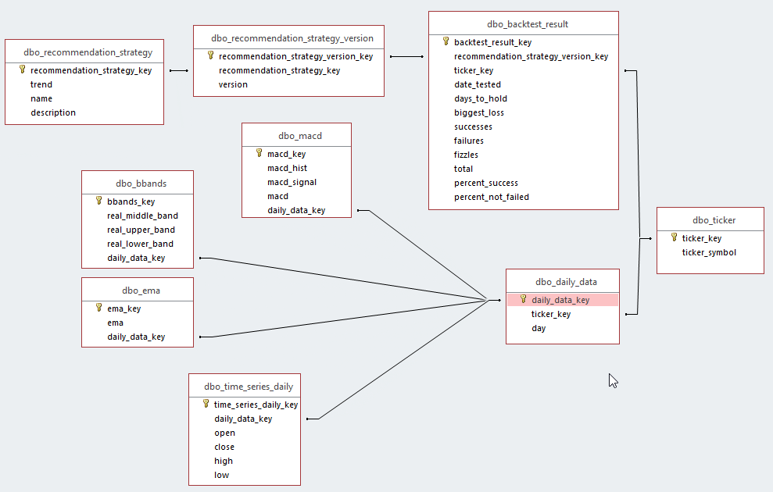

# Business Rules

1. There should be one and only one daily_data_row for a combindation of ticker_key and day.
2. There should only be one and only one row of time_series_daily, ema, bbands, and macd for every row of daily_data.
3. There should be one and only one row of backest_result for every row of recommendation_strategy_version.
4. “Trend” in recommendation_strategy_key can be either ‘BULLISH’ or ‘BEARISH’

# Creation of tables

-- Table: ticker

CREATE TABLE ticker

(

ticker_key INTEGER NOT NULL PRIMARY KEY,

ticker_symbol VARCHAR(200) NOT NULL UNIQUE

)

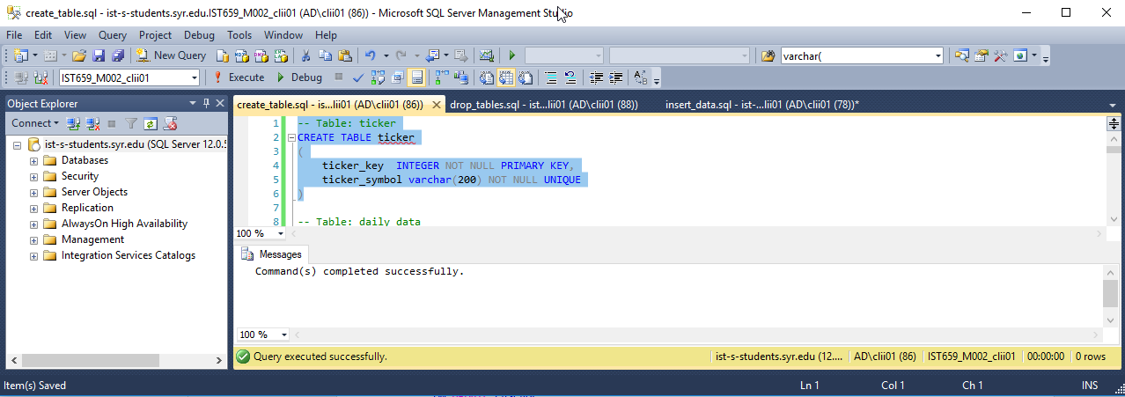

-- Table: daily_data

CREATE TABLE daily_data

(

daily_data_key INTEGER NOT NULL PRIMARY KEY,

ticker_key INTEGER NOT NULL,

"day" date NOT NULL,

CONSTRAINT ticker_key_fk FOREIGN KEY (ticker_key)

REFERENCES ticker (ticker_key)

ON UPDATE CASCADE

ON DELETE CASCADE

)

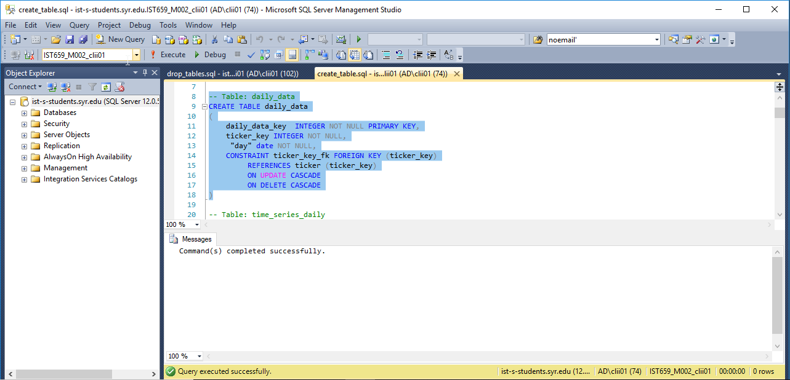

-- Table: time_series_daily

CREATE TABLE time_series_daily

(

time_series_daily_key INTEGER NOT NULL PRIMARY KEY,

daily_data_key integer NOT NULL,

"open" float NOT NULL,

"close" float NOT NULL,

high float NOT NULL,

low float NOT NULL,

CONSTRAINT tma_daily_data_fk FOREIGN KEY (daily_data_key)

REFERENCES daily_data (daily_data_key)

ON UPDATE CASCADE

ON DELETE CASCADE

)

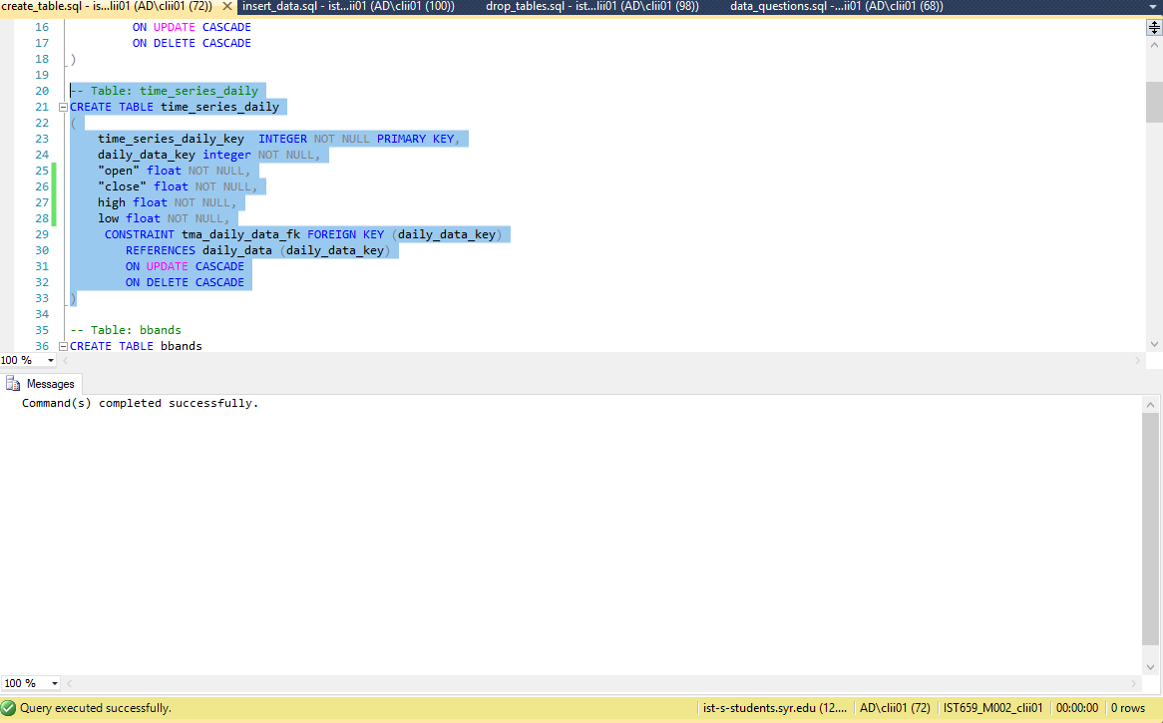

-- Table: bbands

CREATE TABLE bbands

(

bbands_key INTEGER NOT NULL PRIMARY KEY,

real_middle_band float NOT NULL,

real_upper_band float NOT NULL,

real_lower_band float NOT NULL,

daily_data_key INTEGER NOT NULL,

CONSTRAINT bbands_daily_data_fk FOREIGN KEY (daily_data_key)

REFERENCES daily_data (daily_data_key)

ON UPDATE CASCADE

ON DELETE CASCADE

)

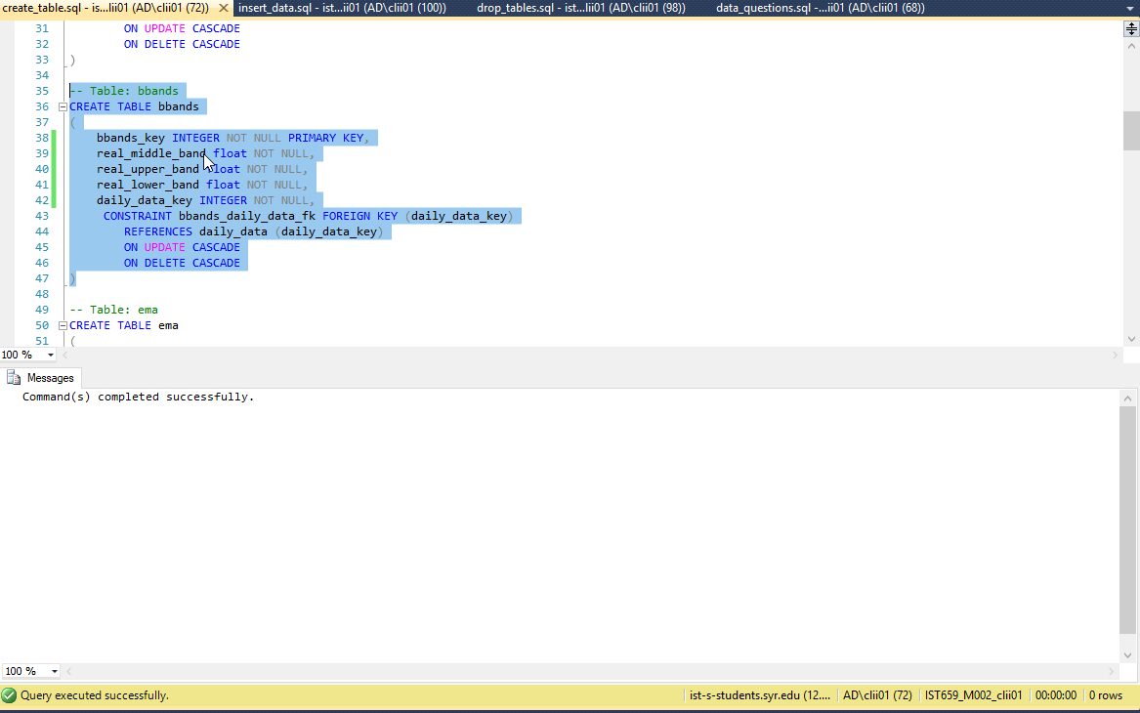

-- Table: ema

CREATE TABLE ema

(

ema_key INTEGER NOT NULL PRIMARY KEY,

ema float NOT NULL,

daily_data_key integer NOT NULL,

CONSTRAINT ema_daily_data_fk FOREIGN KEY (daily_data_key)

REFERENCES daily_data (daily_data_key)

ON UPDATE CASCADE

ON DELETE CASCADE

)

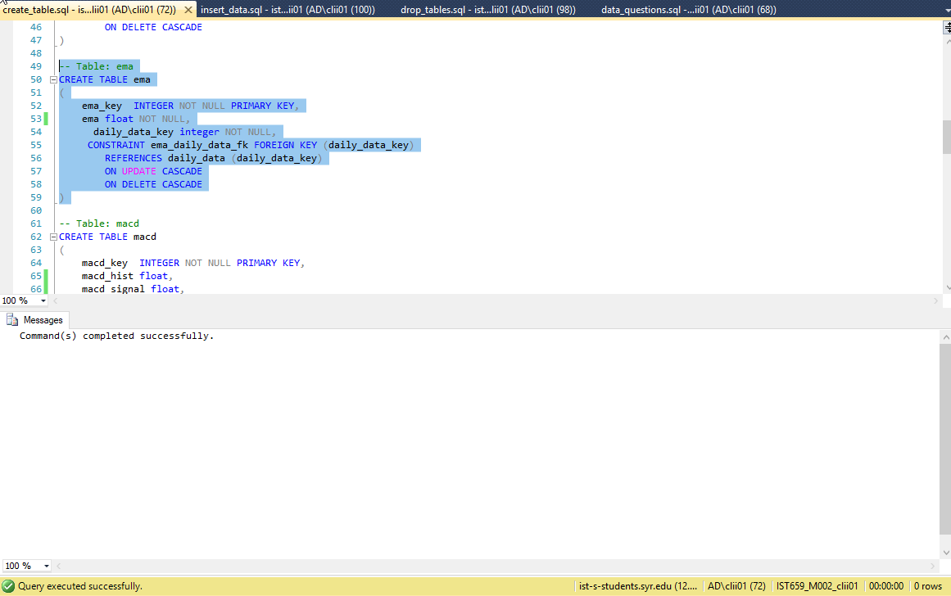

-- Table: macd

CREATE TABLE macd

(

macd_key INTEGER NOT NULL PRIMARY KEY,

macd_hist float,

macd_signal float,

macd float NOT NULL,

daily_data_key integer NOT NULL,

CONSTRAINT macd_daily_data_fk FOREIGN KEY (daily_data_key)

REFERENCES daily_data (daily_data_key)

ON UPDATE CASCADE

ON DELETE CASCADE

)

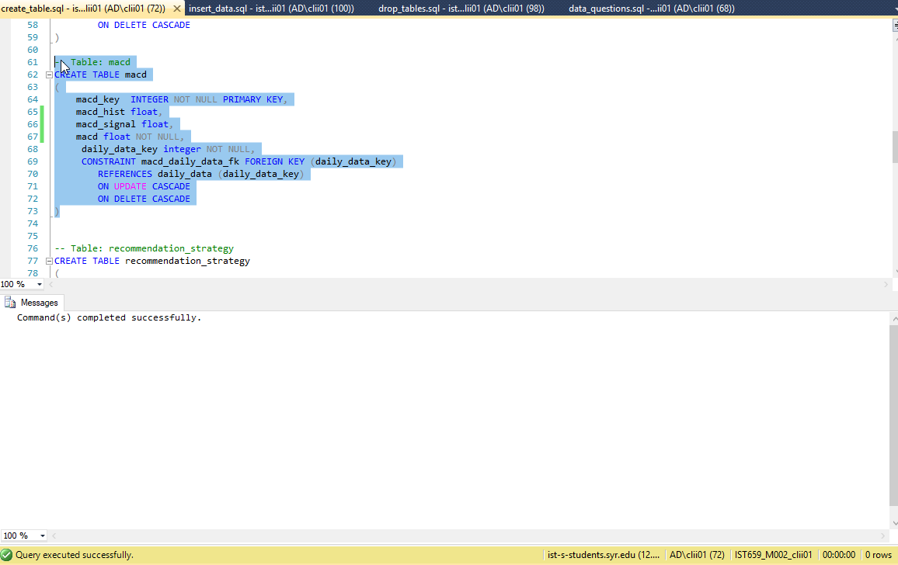

-- Table: recommendation_strategy

CREATE TABLE recommendation_strategy

(

recommendation_strategy_key INTEGER NOT NULL PRIMARY KEY,

trend varchar(200) check (trend = 'BULLISH' OR trend = 'BEARISH'),

name varchar(200) not null,

description varchar(200)

)

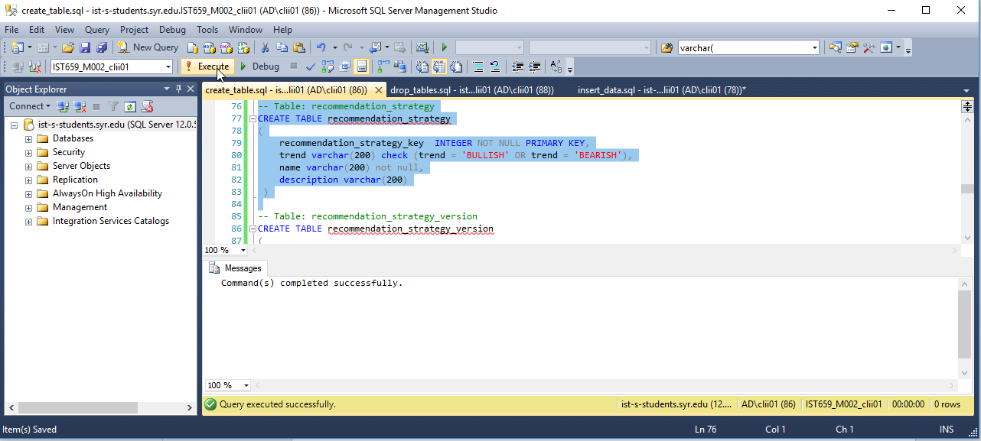

-- Table: recommendation_strategy_version

CREATE TABLE recommendation_strategy_version

(

recommendation_strategy_version_key INTEGER NOT NULL PRIMARY KEY,

recommendation_strategy_key integer NOT NULL,

version integer not null,

CONSTRAINT recommendation_strategy_fk FOREIGN KEY (recommendation_strategy_key)

REFERENCES recommendation_strategy (recommendation_strategy_key)

ON UPDATE CASCADE

ON DELETE CASCADE

)

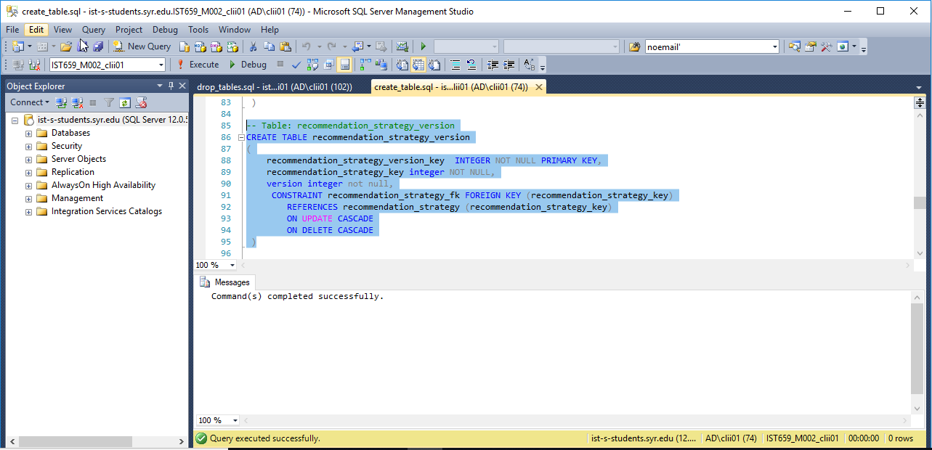

-- Table: backtest_result

create table backtest_result

(

backtest_result_key INTEGER NOT NULL PRIMARY KEY,

recommendation_strategy_version_key integer not null,

ticker_key integer not null,

date_tested date not null,

days_to_hold integer not null,

biggest_loss float not null,

successes integer not null,

failures integer not null,

fizzles integer not null,

total integer not null,

percent_success float not null,

percent_not_failed float not null,

CONSTRAINT backtest_ticker_key_fk FOREIGN KEY (ticker_key)

REFERENCES ticker (ticker_key)

ON UPDATE CASCADE

ON DELETE CASCADE,

CONSTRAINT recommendation_strategy_version_fk FOREIGN KEY (recommendation_strategy_version_key)

REFERENCES recommendation_strategy_version (recommendation_strategy_version_key)

ON UPDATE CASCADE

ON DELETE CASCADE

)

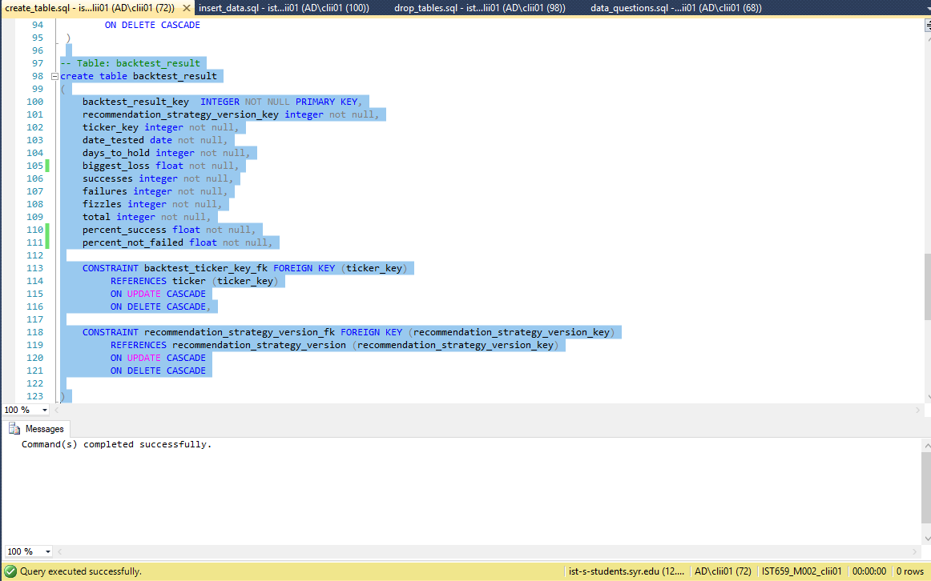

# Insert Statements

-- recommendation strategy table

INSERT INTO recommendation_strategy (recommendation_strategy_key, trend, name) VALUES (1, 'BULLISH', '10 Day EMA Crossing Bullish');

INSERT INTO recommendation_strategy (recommendation_strategy_key, trend, name, description) VALUES (2, 'BEARISH', '10 Day EMA Crossing Bearish', 'Recommends user to buy puts to sell if the stock price average for a day crosses the 10 day ema in a bearish manner');

INSERT INTO recommendation_strategy (recommendation_strategy_key, trend, name, description) VALUES (3, 'BEARISH', 'Bollinger Band Exit Bearish', 'Recommends user to buy puts to sell if the stock price average retreats from the upper Bollinger Band');

INSERT INTO recommendation_strategy (recommendation_strategy_key, trend, name, description) VALUES (4, 'BULLISH', 'Bollinger Band Exit Bullish', 'Recommends user to buy calls to sell if the stock price average retreats from the lower Bollinger Band');

-- recommendation strategy version table

INSERT INTO recommendation_strategy_version (recommendation_strategy_version_key, recommendation_strategy_key, version) VALUES (1, 1, 1);

INSERT INTO recommendation_strategy_version (recommendation_strategy_version_key, recommendation_strategy_key, version) VALUES (2, 2, 1);

INSERT INTO recommendation_strategy_version (recommendation_strategy_version_key, recommendation_strategy_key, version) VALUES (3, 3, 1);

INSERT INTO recommendation_strategy_version (recommendation_strategy_version_key, recommendation_strategy_key, version) VALUES (4, 4, 1);

-- ticker table

INSERT INTO ticker (ticker_key, ticker_symbol) VALUES (1, 'SPY');

INSERT INTO ticker (ticker_key, ticker_symbol) VALUES (2, 'AAPL');

--daily data table

INSERT INTO daily_data (daily_data_key, ticker_key, day) VALUES (1, 1, '2019-02-26');

INSERT INTO daily_data (daily_data_key, ticker_key, day) VALUES (2, 1, '2019-02-25');

INSERT INTO daily_data (daily_data_key, ticker_key, day) VALUES (3, 1, '2019-02-22');

INSERT INTO daily_data (daily_data_key, ticker_key, day) VALUES (4, 1, '2019-02-21');

INSERT INTO daily_data (daily_data_key, ticker_key, day) VALUES (5, 1, '2019-02-20');

INSERT INTO daily_data (daily_data_key, ticker_key, day) VALUES (6, 1, '2019-02-19');

INSERT INTO daily_data (daily_data_key, ticker_key, day) VALUES (7, 1, '2019-02-15');

INSERT INTO daily_data (daily_data_key, ticker_key, day) VALUES (8, 1, '2019-02-14');

INSERT INTO daily_data (daily_data_key, ticker_key, day) VALUES (9, 1, '2019-02-13');

INSERT INTO daily_data (daily_data_key, ticker_key, day) VALUES (10, 1, '2019-02-12');

INSERT INTO daily_data (daily_data_key, ticker_key, day) VALUES (11, 1, '2019-02-11');

INSERT INTO daily_data (daily_data_key, ticker_key, day) VALUES (12, 1, '2019-02-08');

INSERT INTO daily_data (daily_data_key, ticker_key, day) VALUES (13, 1, '2019-02-07');

INSERT INTO daily_data (daily_data_key, ticker_key, day) VALUES (14, 1, '2019-02-06');

INSERT INTO daily_data (daily_data_key, ticker_key, day) VALUES (15, 1, '2019-02-05');

INSERT INTO daily_data (daily_data_key, ticker_key, day) VALUES (16, 1, '2019-02-04');

INSERT INTO daily_data (daily_data_key, ticker_key, day) VALUES (17, 1, '2019-02-01');

INSERT INTO daily_data (daily_data_key, ticker_key, day) VALUES (18, 1, '2019-01-31');

INSERT INTO daily_data (daily_data_key, ticker_key, day) VALUES (19, 1, '2019-01-30');

INSERT INTO daily_data (daily_data_key, ticker_key, day) VALUES (20, 1, '2019-01-29');

INSERT INTO daily_data (daily_data_key, ticker_key, day) VALUES (21, 1, '2019-01-28');

INSERT INTO daily_data (daily_data_key, ticker_key, day) VALUES (22, 1, '2019-01-25');

INSERT INTO daily_data (daily_data_key, ticker_key, day) VALUES (23, 1, '2019-01-24');

INSERT INTO daily_data (daily_data_key, ticker_key, day) VALUES (24, 1, '2019-01-23');

INSERT INTO daily_data (daily_data_key, ticker_key, day) VALUES (25, 1, '2019-01-22');

INSERT INTO daily_data (daily_data_key, ticker_key, day) VALUES (26, 1, '2019-01-18');

INSERT INTO daily_data (daily_data_key, ticker_key, day) VALUES (27, 1, '2019-01-17');

INSERT INTO daily_data (daily_data_key, ticker_key, day) VALUES (28, 1, '2019-01-16');

INSERT INTO daily_data (daily_data_key, ticker_key, day) VALUES (29, 1, '2019-01-15');

INSERT INTO daily_data (daily_data_key, ticker_key, day) VALUES (30, 1, '2019-01-14');

INSERT INTO daily_data (daily_data_key, ticker_key, day) VALUES (31, 1, '2019-01-11');

INSERT INTO daily_data (daily_data_key, ticker_key, day) VALUES (32, 1, '2019-01-10');

INSERT INTO daily_data (daily_data_key, ticker_key, day) VALUES (33, 1, '2019-01-09');

INSERT INTO daily_data (daily_data_key, ticker_key, day) VALUES (34, 1, '2019-01-08');

INSERT INTO daily_data (daily_data_key, ticker_key, day) VALUES (35, 1, '2019-01-07');

INSERT INTO daily_data (daily_data_key, ticker_key, day) VALUES (36, 1, '2019-01-04');

INSERT INTO daily_data (daily_data_key, ticker_key, day) VALUES (37, 1, '2019-01-03');

INSERT INTO daily_data (daily_data_key, ticker_key, day) VALUES (38, 1, '2019-01-02');

INSERT INTO daily_data (daily_data_key, ticker_key, day) VALUES (101, 1, '2019-03-04');

INSERT INTO daily_data (daily_data_key, ticker_key, day) VALUES (102, 1, '2019-03-01');

INSERT INTO daily_data (daily_data_key, ticker_key, day) VALUES (103, 1, '2019-02-28');

INSERT INTO daily_data (daily_data_key, ticker_key, day) VALUES (104, 1, '2019-02-27');

INSERT INTO daily_data (daily_data_key, ticker_key, day) VALUES (105, 1, '2019-03-06');

INSERT INTO daily_data (daily_data_key, ticker_key, day) VALUES (106, 1, '2019-03-05');

INSERT INTO daily_data (daily_data_key, ticker_key, day) VALUES (107, 1, '2019-03-11');

INSERT INTO daily_data (daily_data_key, ticker_key, day) VALUES (108, 1, '2019-03-08');

INSERT INTO daily_data (daily_data_key, ticker_key, day) VALUES (109, 1, '2019-03-07');

INSERT INTO daily_data (daily_data_key, ticker_key, day) VALUES (110, 1, '2019-03-12');

INSERT INTO daily_data (daily_data_key, ticker_key, day) VALUES (111, 1, '2019-03-13');

INSERT INTO daily_data (daily_data_key, ticker_key, day) VALUES (112, 1, '2019-03-15');

INSERT INTO daily_data (daily_data_key, ticker_key, day) VALUES (113, 1, '2019-03-14');

INSERT INTO daily_data (daily_data_key, ticker_key, day) VALUES (114, 1, '2019-03-21');

INSERT INTO daily_data (daily_data_key, ticker_key, day) VALUES (115, 1, '2019-03-20');

INSERT INTO daily_data (daily_data_key, ticker_key, day) VALUES (116, 1, '2019-03-19');

INSERT INTO daily_data (daily_data_key, ticker_key, day) VALUES (117, 1, '2019-03-18');

INSERT INTO daily_data (daily_data_key, ticker_key, day) VALUES (118, 1, '2019-03-22');

INSERT INTO daily_data (daily_data_key, ticker_key, day) VALUES (119, 1, '2019-03-25');

INSERT INTO daily_data (daily_data_key, ticker_key, day) VALUES (120, 1, '2019-03-26');

INSERT INTO daily_data (daily_data_key, ticker_key, day) VALUES (121, 1, '2019-03-27');

INSERT INTO daily_data (daily_data_key, ticker_key, day) VALUES (122, 1, '2019-03-29');

INSERT INTO daily_data (daily_data_key, ticker_key, day) VALUES (123, 1, '2019-03-28');

INSERT INTO daily_data (daily_data_key, ticker_key, day) VALUES (124, 2, '2019-04-01');

INSERT INTO daily_data (daily_data_key, ticker_key, day) VALUES (125, 2, '2019-03-29');

INSERT INTO daily_data (daily_data_key, ticker_key, day) VALUES (126, 2, '2019-03-28');

INSERT INTO daily_data (daily_data_key, ticker_key, day) VALUES (127, 2, '2019-03-27');

INSERT INTO daily_data (daily_data_key, ticker_key, day) VALUES (128, 2, '2019-03-26');

INSERT INTO daily_data (daily_data_key, ticker_key, day) VALUES (129, 2, '2019-03-25');

INSERT INTO daily_data (daily_data_key, ticker_key, day) VALUES (130, 2, '2019-03-22');

INSERT INTO daily_data (daily_data_key, ticker_key, day) VALUES (131, 2, '2019-03-21');

INSERT INTO daily_data (daily_data_key, ticker_key, day) VALUES (132, 2, '2019-03-20');

INSERT INTO daily_data (daily_data_key, ticker_key, day) VALUES (133, 2, '2019-03-19');

INSERT INTO daily_data (daily_data_key, ticker_key, day) VALUES (134, 2, '2019-03-18');

INSERT INTO daily_data (daily_data_key, ticker_key, day) VALUES (135, 2, '2019-03-15');

INSERT INTO daily_data (daily_data_key, ticker_key, day) VALUES (136, 2, '2019-03-14');

INSERT INTO daily_data (daily_data_key, ticker_key, day) VALUES (137, 2, '2019-03-13');

INSERT INTO daily_data (daily_data_key, ticker_key, day) VALUES (138, 2, '2019-03-12');

INSERT INTO daily_data (daily_data_key, ticker_key, day) VALUES (139, 2, '2019-03-11');

INSERT INTO daily_data (daily_data_key, ticker_key, day) VALUES (140, 2, '2019-03-08');

INSERT INTO daily_data (daily_data_key, ticker_key, day) VALUES (141, 2, '2019-03-07');

INSERT INTO daily_data (daily_data_key, ticker_key, day) VALUES (142, 2, '2019-03-06');

INSERT INTO daily_data (daily_data_key, ticker_key, day) VALUES (143, 2, '2019-03-05');

INSERT INTO daily_data (daily_data_key, ticker_key, day) VALUES (144, 2, '2019-03-04');

INSERT INTO daily_data (daily_data_key, ticker_key, day) VALUES (145, 2, '2019-03-01');

INSERT INTO daily_data (daily_data_key, ticker_key, day) VALUES (146, 2, '2019-02-28');

INSERT INTO daily_data (daily_data_key, ticker_key, day) VALUES (147, 2, '2019-02-27');

INSERT INTO daily_data (daily_data_key, ticker_key, day) VALUES (148, 2, '2019-02-26');

INSERT INTO daily_data (daily_data_key, ticker_key, day) VALUES (149, 2, '2019-02-25');

INSERT INTO daily_data (daily_data_key, ticker_key, day) VALUES (150, 2, '2019-02-22');

INSERT INTO daily_data (daily_data_key, ticker_key, day) VALUES (151, 2, '2019-02-21');

INSERT INTO daily_data (daily_data_key, ticker_key, day) VALUES (152, 2, '2019-02-20');

INSERT INTO daily_data (daily_data_key, ticker_key, day) VALUES (153, 2, '2019-02-19');

INSERT INTO daily_data (daily_data_key, ticker_key, day) VALUES (154, 2, '2019-02-15');

INSERT INTO daily_data (daily_data_key, ticker_key, day) VALUES (155, 2, '2019-02-14');

INSERT INTO daily_data (daily_data_key, ticker_key, day) VALUES (156, 2, '2019-02-13');

INSERT INTO daily_data (daily_data_key, ticker_key, day) VALUES (157, 2, '2019-02-12');

INSERT INTO daily_data (daily_data_key, ticker_key, day) VALUES (158, 2, '2019-02-11');

INSERT INTO daily_data (daily_data_key, ticker_key, day) VALUES (159, 2, '2019-02-08');

INSERT INTO daily_data (daily_data_key, ticker_key, day) VALUES (160, 2, '2019-02-07');

INSERT INTO daily_data (daily_data_key, ticker_key, day) VALUES (161, 2, '2019-02-06');

INSERT INTO daily_data (daily_data_key, ticker_key, day) VALUES (162, 2, '2019-02-05');

INSERT INTO daily_data (daily_data_key, ticker_key, day) VALUES (163, 2, '2019-02-04');

INSERT INTO daily_data (daily_data_key, ticker_key, day) VALUES (164, 2, '2019-02-01');

INSERT INTO daily_data (daily_data_key, ticker_key, day) VALUES (165, 2, '2019-01-31');

INSERT INTO daily_data (daily_data_key, ticker_key, day) VALUES (166, 2, '2019-01-30');

INSERT INTO daily_data (daily_data_key, ticker_key, day) VALUES (167, 2, '2019-01-29');

INSERT INTO daily_data (daily_data_key, ticker_key, day) VALUES (168, 2, '2019-01-28');

INSERT INTO daily_data (daily_data_key, ticker_key, day) VALUES (169, 2, '2019-01-25');

INSERT INTO daily_data (daily_data_key, ticker_key, day) VALUES (170, 2, '2019-01-24');

INSERT INTO daily_data (daily_data_key, ticker_key, day) VALUES (171, 2, '2019-01-23');

INSERT INTO daily_data (daily_data_key, ticker_key, day) VALUES (172, 2, '2019-01-22');

INSERT INTO daily_data (daily_data_key, ticker_key, day) VALUES (173, 2, '2019-01-18');

INSERT INTO daily_data (daily_data_key, ticker_key, day) VALUES (174, 2, '2019-01-17');

INSERT INTO daily_data (daily_data_key, ticker_key, day) VALUES (175, 2, '2019-01-16');

INSERT INTO daily_data (daily_data_key, ticker_key, day) VALUES (176, 2, '2019-01-15');

INSERT INTO daily_data (daily_data_key, ticker_key, day) VALUES (177, 2, '2019-01-14');

INSERT INTO daily_data (daily_data_key, ticker_key, day) VALUES (178, 2, '2019-01-11');

INSERT INTO daily_data (daily_data_key, ticker_key, day) VALUES (179, 2, '2019-01-10');

INSERT INTO daily_data (daily_data_key, ticker_key, day) VALUES (180, 2, '2019-01-09');

INSERT INTO daily_data (daily_data_key, ticker_key, day) VALUES (181, 2, '2019-01-08');

INSERT INTO daily_data (daily_data_key, ticker_key, day) VALUES (182, 2, '2019-01-07');

INSERT INTO daily_data (daily_data_key, ticker_key, day) VALUES (183, 2, '2019-01-04');

INSERT INTO daily_data (daily_data_key, ticker_key, day) VALUES (184, 2, '2019-01-03');

INSERT INTO daily_data (daily_data_key, ticker_key, day) VALUES (185, 2, '2019-01-02');

INSERT INTO daily_data (daily_data_key, ticker_key, day) VALUES (224, 1, '2019-04-02');

INSERT INTO daily_data (daily_data_key, ticker_key, day) VALUES (225, 1, '2019-04-01');

--bbands table

INSERT INTO bbands (bbands_key, real_middle_band, real_upper_band, real_lower_band, daily_data_key) VALUES (1, 275.4621, 282.0974, 268.8269, 1);

INSERT INTO bbands (bbands_key, real_middle_band, real_upper_band, real_lower_band, daily_data_key) VALUES (2, 275.0179, 281.3880, 268.6477, 2);

INSERT INTO bbands (bbands_key, real_middle_band, real_upper_band, real_lower_band, daily_data_key) VALUES (3, 274.4779, 280.5022, 268.4535, 3);

INSERT INTO bbands (bbands_key, real_middle_band, real_upper_band, real_lower_band, daily_data_key) VALUES (4, 273.8293, 279.6582, 268.0003, 4);

INSERT INTO bbands (bbands_key, real_middle_band, real_upper_band, real_lower_band, daily_data_key) VALUES (5, 273.2943, 279.0815, 267.5071, 5);

INSERT INTO bbands (bbands_key, real_middle_band, real_upper_band, real_lower_band, daily_data_key) VALUES (6, 272.5207, 278.2610, 266.7805, 6);

INSERT INTO bbands (bbands_key, real_middle_band, real_upper_band, real_lower_band, daily_data_key) VALUES (7, 271.4893, 278.1448, 264.8337, 7);

INSERT INTO bbands (bbands_key, real_middle_band, real_upper_band, real_lower_band, daily_data_key) VALUES (8, 270.5171, 277.4240, 263.6103, 8);

INSERT INTO bbands (bbands_key, real_middle_band, real_upper_band, real_lower_band, daily_data_key) VALUES (9, 269.9029, 276.8558, 262.9499, 9);

INSERT INTO bbands (bbands_key, real_middle_band, real_upper_band, real_lower_band, daily_data_key) VALUES (10, 269.0857, 276.1433, 262.0281, 10);

INSERT INTO bbands (bbands_key, real_middle_band, real_upper_band, real_lower_band, daily_data_key) VALUES (11, 268.3221, 275.3576, 261.2867, 11);

INSERT INTO bbands (bbands_key, real_middle_band, real_upper_band, real_lower_band, daily_data_key) VALUES (12, 267.7679, 275.2032, 260.3325, 12);

INSERT INTO bbands (bbands_key, real_middle_band, real_upper_band, real_lower_band, daily_data_key) VALUES (13, 267.4814, 274.7861, 260.1767, 13);

INSERT INTO bbands (bbands_key, real_middle_band, real_upper_band, real_lower_band, daily_data_key) VALUES (14, 266.9686, 274.4604, 259.4767, 14);

INSERT INTO bbands (bbands_key, real_middle_band, real_upper_band, real_lower_band, daily_data_key) VALUES (15, 266.1286, 273.4794, 258.7777, 15);

INSERT INTO bbands (bbands_key, real_middle_band, real_upper_band, real_lower_band, daily_data_key) VALUES (16, 265.2179, 272.0276, 258.4081, 16);

INSERT INTO bbands (bbands_key, real_middle_band, real_upper_band, real_lower_band, daily_data_key) VALUES (17, 264.1779, 270.9985, 257.3572, 17);

INSERT INTO bbands (bbands_key, real_middle_band, real_upper_band, real_lower_band, daily_data_key) VALUES (18, 263.3864, 269.8555, 256.9173, 18);

INSERT INTO bbands (bbands_key, real_middle_band, real_upper_band, real_lower_band, daily_data_key) VALUES (19, 262.5971, 268.3352, 256.8591, 19);

INSERT INTO bbands (bbands_key, real_middle_band, real_upper_band, real_lower_band, daily_data_key) VALUES (20, 261.9107, 267.3938, 256.4276, 20);

INSERT INTO bbands (bbands_key, real_middle_band, real_upper_band, real_lower_band, daily_data_key) VALUES (21, 261.4364, 267.4425, 255.4304, 21);

INSERT INTO bbands (bbands_key, real_middle_band, real_upper_band, real_lower_band, daily_data_key) VALUES (22, 260.7664, 267.6192, 253.9136, 22);

INSERT INTO bbands (bbands_key, real_middle_band, real_upper_band, real_lower_band, daily_data_key) VALUES (23, 259.8100, 267.3045, 252.3155, 23);

INSERT INTO bbands (bbands_key, real_middle_band, real_upper_band, real_lower_band, daily_data_key) VALUES (24, 258.4286, 269.1089, 247.7483, 24);

INSERT INTO bbands (bbands_key, real_middle_band, real_upper_band, real_lower_band, daily_data_key) VALUES (25, 257.4836, 268.5672, 246.3999, 25);

INSERT INTO bbands (bbands_key, real_middle_band, real_upper_band, real_lower_band, daily_data_key) VALUES (26, 256.5593, 267.8516, 245.2670, 26);

INSERT INTO bbands (bbands_key, real_middle_band, real_upper_band, real_lower_band, daily_data_key) VALUES (27, 255.2229, 265.9251, 244.5207, 27);

INSERT INTO bbands (bbands_key, real_middle_band, real_upper_band, real_lower_band, daily_data_key) VALUES (28, 254.1593, 264.5288, 243.7898, 28);

INSERT INTO bbands (bbands_key, real_middle_band, real_upper_band, real_lower_band, daily_data_key) VALUES (29, 253.1021, 263.4923, 242.7120, 29);

INSERT INTO bbands (bbands_key, real_middle_band, real_upper_band, real_lower_band, daily_data_key) VALUES (30, 251.2443, 264.6501, 237.8384, 30);

INSERT INTO bbands (bbands_key, real_middle_band, real_upper_band, real_lower_band, daily_data_key) VALUES (31, 250.0514, 264.0144, 236.0885, 31);

INSERT INTO bbands (bbands_key, real_middle_band, real_upper_band, real_lower_band, daily_data_key) VALUES (32, 249.2079, 262.3118, 236.1039, 32);

INSERT INTO bbands (bbands_key, real_middle_band, real_upper_band, real_lower_band, daily_data_key) VALUES (33, 248.6636, 260.7053, 236.6219, 33);

INSERT INTO bbands (bbands_key, real_middle_band, real_upper_band, real_lower_band, daily_data_key) VALUES (34, 248.4571, 259.9397, 236.9745, 34);

INSERT INTO bbands (bbands_key, real_middle_band, real_upper_band, real_lower_band, daily_data_key) VALUES (35, 248.3564, 259.5671, 237.1457, 35);

INSERT INTO bbands (bbands_key, real_middle_band, real_upper_band, real_lower_band, daily_data_key) VALUES (36, 248.7914, 261.3007, 236.2822, 36);

INSERT INTO bbands (bbands_key, real_middle_band, real_upper_band, real_lower_band, daily_data_key) VALUES (37, 249.7186, 264.8140, 234.6232, 37);

INSERT INTO bbands (bbands_key, real_middle_band, real_upper_band, real_lower_band, daily_data_key) VALUES (38, 251.2364, 267.9930, 234.4798, 38);

INSERT INTO bbands (bbands_key, real_middle_band, real_upper_band, real_lower_band, daily_data_key) VALUES (101, 277.8700, 281.7642, 273.9758, 101);

INSERT INTO bbands (bbands_key, real_middle_band, real_upper_band, real_lower_band, daily_data_key) VALUES (102, 277.2443, 282.5325, 271.9561, 102);

INSERT INTO bbands (bbands_key, real_middle_band, real_upper_band, real_lower_band, daily_data_key) VALUES (103, 276.5336, 282.5481, 270.5190, 103);

INSERT INTO bbands (bbands_key, real_middle_band, real_upper_band, real_lower_band, daily_data_key) VALUES (104, 275.9236, 282.6355, 269.2117, 104);

INSERT INTO bbands (bbands_key, real_middle_band, real_upper_band, real_lower_band, daily_data_key) VALUES (105, 278.3900, 281.2415, 275.5385, 105);

INSERT INTO bbands (bbands_key, real_middle_band, real_upper_band, real_lower_band, daily_data_key) VALUES (106, 278.2229, 281.5397, 274.9060, 106);

INSERT INTO bbands (bbands_key, real_middle_band, real_upper_band, real_lower_band, daily_data_key) VALUES (107, 278.2146, 281.5095, 274.9197, 107);

INSERT INTO bbands (bbands_key, real_middle_band, real_upper_band, real_lower_band, daily_data_key) VALUES (108, 278.2271, 281.5151, 274.9392, 108);

INSERT INTO bbands (bbands_key, real_middle_band, real_upper_band, real_lower_band, daily_data_key) VALUES (109, 278.4350, 281.0413, 275.8287, 109);

INSERT INTO bbands (bbands_key, real_middle_band, real_upper_band, real_lower_band, daily_data_key) VALUES (110, 278.3464, 281.6889, 275.0040, 110);

INSERT INTO bbands (bbands_key, real_middle_band, real_upper_band, real_lower_band, daily_data_key) VALUES (111, 278.6264, 282.2560, 274.9969, 111);

INSERT INTO bbands (bbands_key, real_middle_band, real_upper_band, real_lower_band, daily_data_key) VALUES (112, 278.8986, 282.9563, 274.8408, 112);

INSERT INTO bbands (bbands_key, real_middle_band, real_upper_band, real_lower_band, daily_data_key) VALUES (113, 278.7707, 282.6242, 274.9173, 113);

INSERT INTO bbands (bbands_key, real_middle_band, real_upper_band, real_lower_band, daily_data_key) VALUES (114, 279.7957, 285.1358, 274.4556, 114);

INSERT INTO bbands (bbands_key, real_middle_band, real_upper_band, real_lower_band, daily_data_key) VALUES (115, 279.5471, 284.4019, 274.6924, 115);

INSERT INTO bbands (bbands_key, real_middle_band, real_upper_band, real_lower_band, daily_data_key) VALUES (116, 279.3421, 284.0823, 274.6020, 116);

INSERT INTO bbands (bbands_key, real_middle_band, real_upper_band, real_lower_band, daily_data_key) VALUES (117, 279.1136, 283.5401, 274.6871, 117);

INSERT INTO bbands (bbands_key, real_middle_band, real_upper_band, real_lower_band, daily_data_key) VALUES (118, 279.8443, 285.3843, 274.3043, 118);

INSERT INTO bbands (bbands_key, real_middle_band, real_upper_band, real_lower_band, daily_data_key) VALUES (119, 279.8457, 285.3848, 274.3066, 119);

INSERT INTO bbands (bbands_key, real_middle_band, real_upper_band, real_lower_band, daily_data_key) VALUES (120, 280.1164, 285.5057, 274.7271, 120);

INSERT INTO bbands (bbands_key, real_middle_band, real_upper_band, real_lower_band, daily_data_key) VALUES (121, 280.4479, 285.0541, 275.8417, 121);

INSERT INTO bbands (bbands_key, real_middle_band, real_upper_band, real_lower_band, daily_data_key) VALUES (122, 281.1829, 284.1594, 278.2063, 122);

INSERT INTO bbands (bbands_key, real_middle_band, real_upper_band, real_lower_band, daily_data_key) VALUES (123, 280.8943, 284.0873, 277.7013, 123);

INSERT INTO bbands (bbands_key, real_middle_band, real_upper_band, real_lower_band, daily_data_key) VALUES (124, 188.1471, 194.4314, 181.8629, 124);

INSERT INTO bbands (bbands_key, real_middle_band, real_upper_band, real_lower_band, daily_data_key) VALUES (125, 187.4279, 194.5055, 180.3502, 125);

INSERT INTO bbands (bbands_key, real_middle_band, real_upper_band, real_lower_band, daily_data_key) VALUES (126, 186.6386, 194.7972, 178.4800, 126);

INSERT INTO bbands (bbands_key, real_middle_band, real_upper_band, real_lower_band, daily_data_key) VALUES (127, 185.5093, 196.1898, 174.8288, 127);

INSERT INTO bbands (bbands_key, real_middle_band, real_upper_band, real_lower_band, daily_data_key) VALUES (128, 184.3686, 196.8072, 171.9300, 128);

INSERT INTO bbands (bbands_key, real_middle_band, real_upper_band, real_lower_band, daily_data_key) VALUES (129, 183.4921, 196.8219, 170.1623, 129);

INSERT INTO bbands (bbands_key, real_middle_band, real_upper_band, real_lower_band, daily_data_key) VALUES (130, 182.5486, 196.1267, 168.9704, 130);

INSERT INTO bbands (bbands_key, real_middle_band, real_upper_band, real_lower_band, daily_data_key) VALUES (131, 181.4629, 194.5709, 168.3548, 131);

INSERT INTO bbands (bbands_key, real_middle_band, real_upper_band, real_lower_band, daily_data_key) VALUES (132, 180.0257, 191.0959, 168.9555, 132);

INSERT INTO bbands (bbands_key, real_middle_band, real_upper_band, real_lower_band, daily_data_key) VALUES (133, 178.9536, 189.5627, 168.3445, 133);

INSERT INTO bbands (bbands_key, real_middle_band, real_upper_band, real_lower_band, daily_data_key) VALUES (134, 178.1207, 188.0274, 168.2140, 134);

INSERT INTO bbands (bbands_key, real_middle_band, real_upper_band, real_lower_band, daily_data_key) VALUES (135, 177.1429, 185.5348, 168.7509, 135);

INSERT INTO bbands (bbands_key, real_middle_band, real_upper_band, real_lower_band, daily_data_key) VALUES (136, 176.2936, 183.1447, 169.4425, 136);

INSERT INTO bbands (bbands_key, real_middle_band, real_upper_band, real_lower_band, daily_data_key) VALUES (137, 175.5250, 181.1757, 169.8743, 137);

INSERT INTO bbands (bbands_key, real_middle_band, real_upper_band, real_lower_band, daily_data_key) VALUES (138, 174.7643, 179.7021, 169.8264, 138);

INSERT INTO bbands (bbands_key, real_middle_band, real_upper_band, real_lower_band, daily_data_key) VALUES (139, 174.1300, 177.8874, 170.3726, 139);

INSERT INTO bbands (bbands_key, real_middle_band, real_upper_band, real_lower_band, daily_data_key) VALUES (140, 173.5607, 176.6015, 170.5199, 140);

INSERT INTO bbands (bbands_key, real_middle_band, real_upper_band, real_lower_band, daily_data_key) VALUES (141, 173.3829, 176.8205, 169.9452, 141);

INSERT INTO bbands (bbands_key, real_middle_band, real_upper_band, real_lower_band, daily_data_key) VALUES (142, 173.2614, 176.9277, 169.5951, 142);

INSERT INTO bbands (bbands_key, real_middle_band, real_upper_band, real_lower_band, daily_data_key) VALUES (143, 172.9514, 176.8652, 169.0377, 143);

INSERT INTO bbands (bbands_key, real_middle_band, real_upper_band, real_lower_band, daily_data_key) VALUES (144, 172.6200, 176.3873, 168.8527, 144);

INSERT INTO bbands (bbands_key, real_middle_band, real_upper_band, real_lower_band, daily_data_key) VALUES (145, 172.1614, 175.8053, 168.5175, 145);

INSERT INTO bbands (bbands_key, real_middle_band, real_upper_band, real_lower_band, daily_data_key) VALUES (146, 171.8357, 175.2234, 168.4480, 146);

INSERT INTO bbands (bbands_key, real_middle_band, real_upper_band, real_lower_band, daily_data_key) VALUES (147, 171.6779, 175.0114, 168.3443, 147);

INSERT INTO bbands (bbands_key, real_middle_band, real_upper_band, real_lower_band, daily_data_key) VALUES (148, 171.6329, 174.8060, 168.4598, 148);

INSERT INTO bbands (bbands_key, real_middle_band, real_upper_band, real_lower_band, daily_data_key) VALUES (149, 171.6221, 174.7596, 168.4847, 149);

INSERT INTO bbands (bbands_key, real_middle_band, real_upper_band, real_lower_band, daily_data_key) VALUES (150, 171.4093, 174.1947, 168.6239, 150);

INSERT INTO bbands (bbands_key, real_middle_band, real_upper_band, real_lower_band, daily_data_key) VALUES (151, 170.9486, 174.5602, 167.3370, 151);

INSERT INTO bbands (bbands_key, real_middle_band, real_upper_band, real_lower_band, daily_data_key) VALUES (152, 170.6186, 174.9095, 166.3276, 152);

INSERT INTO bbands (bbands_key, real_middle_band, real_upper_band, real_lower_band, daily_data_key) VALUES (153, 170.1343, 175.1482, 165.1203, 153);

INSERT INTO bbands (bbands_key, real_middle_band, real_upper_band, real_lower_band, daily_data_key) VALUES (154, 168.9736, 178.3442, 159.6030, 154);

INSERT INTO bbands (bbands_key, real_middle_band, real_upper_band, real_lower_band, daily_data_key) VALUES (155, 167.9650, 179.3243, 156.6057, 155);

INSERT INTO bbands (bbands_key, real_middle_band, real_upper_band, real_lower_band, daily_data_key) VALUES (156, 167.0336, 179.4037, 154.6634, 156);

INSERT INTO bbands (bbands_key, real_middle_band, real_upper_band, real_lower_band, daily_data_key) VALUES (157, 165.7850, 180.0208, 151.5492, 157);

INSERT INTO bbands (bbands_key, real_middle_band, real_upper_band, real_lower_band, daily_data_key) VALUES (158, 164.5729, 179.7240, 149.4217, 158);

INSERT INTO bbands (bbands_key, real_middle_band, real_upper_band, real_lower_band, daily_data_key) VALUES (159, 163.4207, 179.3523, 147.4892, 159);

INSERT INTO bbands (bbands_key, real_middle_band, real_upper_band, real_lower_band, daily_data_key) VALUES (160, 162.4500, 178.2150, 146.6850, 160);

INSERT INTO bbands (bbands_key, real_middle_band, real_upper_band, real_lower_band, daily_data_key) VALUES (161, 161.3729, 176.7257, 146.0200, 161);

INSERT INTO bbands (bbands_key, real_middle_band, real_upper_band, real_lower_band, daily_data_key) VALUES (162, 159.9943, 173.8733, 146.1153, 162);

INSERT INTO bbands (bbands_key, real_middle_band, real_upper_band, real_lower_band, daily_data_key) VALUES (163, 158.4864, 170.3074, 146.6655, 163);

INSERT INTO bbands (bbands_key, real_middle_band, real_upper_band, real_lower_band, daily_data_key) VALUES (164, 156.9686, 167.1936, 146.7435, 164);

INSERT INTO bbands (bbands_key, real_middle_band, real_upper_band, real_lower_band, daily_data_key) VALUES (165, 155.9521, 164.9303, 146.9740, 165);

INSERT INTO bbands (bbands_key, real_middle_band, real_upper_band, real_lower_band, daily_data_key) VALUES (166, 155.0493, 161.9226, 148.1760, 166);

INSERT INTO bbands (bbands_key, real_middle_band, real_upper_band, real_lower_band, daily_data_key) VALUES (167, 154.1964, 158.1293, 150.2635, 167);

INSERT INTO bbands (bbands_key, real_middle_band, real_upper_band, real_lower_band, daily_data_key) VALUES (168, 153.9157, 158.2145, 149.6170, 168);

INSERT INTO bbands (bbands_key, real_middle_band, real_upper_band, real_lower_band, daily_data_key) VALUES (169, 153.3179, 158.3836, 148.2521, 169);

INSERT INTO bbands (bbands_key, real_middle_band, real_upper_band, real_lower_band, daily_data_key) VALUES (170, 152.6393, 157.6882, 147.5904, 170);

INSERT INTO bbands (bbands_key, real_middle_band, real_upper_band, real_lower_band, daily_data_key) VALUES (171, 151.8886, 159.2664, 144.5107, 171);

INSERT INTO bbands (bbands_key, real_middle_band, real_upper_band, real_lower_band, daily_data_key) VALUES (172, 152.1743, 160.1317, 144.2168, 172);

INSERT INTO bbands (bbands_key, real_middle_band, real_upper_band, real_lower_band, daily_data_key) VALUES (173, 152.4914, 160.9417, 144.0412, 173);

INSERT INTO bbands (bbands_key, real_middle_band, real_upper_band, real_lower_band, daily_data_key) VALUES (174, 152.4493, 160.8183, 144.0803, 174);

INSERT INTO bbands (bbands_key, real_middle_band, real_upper_band, real_lower_band, daily_data_key) VALUES (175, 152.4700, 160.8740, 144.0660, 175);

INSERT INTO bbands (bbands_key, real_middle_band, real_upper_band, real_lower_band, daily_data_key) VALUES (176, 152.6293, 161.2950, 143.9636, 176);

INSERT INTO bbands (bbands_key, real_middle_band, real_upper_band, real_lower_band, daily_data_key) VALUES (177, 152.1836, 161.3407, 143.0264, 177);

INSERT INTO bbands (bbands_key, real_middle_band, real_upper_band, real_lower_band, daily_data_key) VALUES (178, 152.2357, 161.3507, 143.1207, 178);

INSERT INTO bbands (bbands_key, real_middle_band, real_upper_band, real_lower_band, daily_data_key) VALUES (179, 152.5600, 161.9777, 143.1423, 179);

INSERT INTO bbands (bbands_key, real_middle_band, real_upper_band, real_lower_band, daily_data_key) VALUES (180, 153.0664, 163.4131, 142.7198, 180);

INSERT INTO bbands (bbands_key, real_middle_band, real_upper_band, real_lower_band, daily_data_key) VALUES (181, 153.9779, 166.3077, 141.6480, 181);

INSERT INTO bbands (bbands_key, real_middle_band, real_upper_band, real_lower_band, daily_data_key) VALUES (182, 154.9200, 168.1054, 141.7346, 182);

INSERT INTO bbands (bbands_key, real_middle_band, real_upper_band, real_lower_band, daily_data_key) VALUES (183, 156.1736, 169.7923, 142.5549, 183);

INSERT INTO bbands (bbands_key, real_middle_band, real_upper_band, real_lower_band, daily_data_key) VALUES (184, 157.7943, 172.6082, 142.9803, 184);

INSERT INTO bbands (bbands_key, real_middle_band, real_upper_band, real_lower_band, daily_data_key) VALUES (185, 159.7164, 172.8170, 146.6159, 185);

INSERT INTO bbands (bbands_key, real_middle_band, real_upper_band, real_lower_band, daily_data_key) VALUES (224, 281.9586, 286.2068, 277.7103, 224);

INSERT INTO bbands (bbands_key, real_middle_band, real_upper_band, real_lower_band, daily_data_key) VALUES (225, 281.6357, 285.2951, 277.9764, 225);

-- ema table

INSERT INTO ema (ema_key, ema, daily_data_key) VALUES (1, 277.0123, 1);

INSERT INTO ema (ema_key, ema, daily_data_key) VALUES (2, 276.4995, 2);

INSERT INTO ema (ema_key, ema, daily_data_key) VALUES (3, 275.8282, 3);

INSERT INTO ema (ema_key, ema, daily_data_key) VALUES (4, 275.0923, 4);

INSERT INTO ema (ema_key, ema, daily_data_key) VALUES (5, 274.5750, 5);

INSERT INTO ema (ema_key, ema, daily_data_key) VALUES (6, 273.7228, 6);

INSERT INTO ema (ema_key, ema, daily_data_key) VALUES (7, 272.8057, 7);

INSERT INTO ema (ema_key, ema, daily_data_key) VALUES (8, 271.7914, 8);

INSERT INTO ema (ema_key, ema, daily_data_key) VALUES (9, 271.2161, 9);

INSERT INTO ema (ema_key, ema, daily_data_key) VALUES (10, 270.3774, 10);

INSERT INTO ema (ema_key, ema, daily_data_key) VALUES (11, 269.5502, 11);

INSERT INTO ema (ema_key, ema, daily_data_key) VALUES (12, 269.3125, 12);

INSERT INTO ema (ema_key, ema, daily_data_key) VALUES (13, 269.0553, 13);

INSERT INTO ema (ema_key, ema, daily_data_key) VALUES (14, 268.8142, 14);

INSERT INTO ema (ema_key, ema, daily_data_key) VALUES (15, 267.9418, 15);

INSERT INTO ema (ema_key, ema, daily_data_key) VALUES (16, 266.7955, 16);

INSERT INTO ema (ema_key, ema, daily_data_key) VALUES (17, 265.6479, 17);

INSERT INTO ema (ema_key, ema, daily_data_key) VALUES (18, 264.6674, 18);

INSERT INTO ema (ema_key, ema, daily_data_key) VALUES (19, 263.4980, 19);

INSERT INTO ema (ema_key, ema, daily_data_key) VALUES (20, 262.5908, 20);

INSERT INTO ema (ema_key, ema, daily_data_key) VALUES (21, 262.4088, 21);

INSERT INTO ema (ema_key, ema, daily_data_key) VALUES (22, 262.1085, 22);

INSERT INTO ema (ema_key, ema, daily_data_key) VALUES (23, 261.2926, 23);

INSERT INTO ema (ema_key, ema, daily_data_key) VALUES (24, 260.7910, 24);

INSERT INTO ema (ema_key, ema, daily_data_key) VALUES (25, 260.2090, 25);

INSERT INTO ema (ema_key, ema, daily_data_key) VALUES (26, 259.6199, 26);

INSERT INTO ema (ema_key, ema, daily_data_key) VALUES (27, 258.0999, 27);

INSERT INTO ema (ema_key, ema, daily_data_key) VALUES (28, 257.0199, 28);

INSERT INTO ema (ema_key, ema, daily_data_key) VALUES (29, 256.1398, 29);

INSERT INTO ema (ema_key, ema, daily_data_key) VALUES (30, 255.2042, 30);

INSERT INTO ema (ema_key, ema, daily_data_key) VALUES (31, 254.7163, 31);

INSERT INTO ema (ema_key, ema, daily_data_key) VALUES (32, 253.7688, 32);

INSERT INTO ema (ema_key, ema, daily_data_key) VALUES (33, 252.6330, 33);

INSERT INTO ema (ema_key, ema, daily_data_key) VALUES (34, 251.4469, 34);

INSERT INTO ema (ema_key, ema, daily_data_key) VALUES (35, 250.2640, 35);

INSERT INTO ema (ema_key, ema, daily_data_key) VALUES (36, 249.3494, 36);

INSERT INTO ema (ema_key, ema, daily_data_key) VALUES (37, 248.6737, 37);

INSERT INTO ema (ema_key, ema, daily_data_key) VALUES (38, 249.6656, 38);

INSERT INTO ema (ema_key, ema, daily_data_key) VALUES (101, 278.3706, 101);

INSERT INTO ema (ema_key, ema, daily_data_key) VALUES (102, 278.1462, 102);

INSERT INTO ema (ema_key, ema, daily_data_key) VALUES (103, 277.6410, 103);

INSERT INTO ema (ema_key, ema, daily_data_key) VALUES (104, 277.4101, 104);

INSERT INTO ema (ema_key, ema, daily_data_key) VALUES (105, 278.2804, 105);

INSERT INTO ema (ema_key, ema, daily_data_key) VALUES (106, 278.4916, 106);

INSERT INTO ema (ema_key, ema, daily_data_key) VALUES (107, 277.1976, 107);

INSERT INTO ema (ema_key, ema, daily_data_key) VALUES (108, 277.0993, 108);

INSERT INTO ema (ema_key, ema, daily_data_key) VALUES (109, 277.6858, 109);

INSERT INTO ema (ema_key, ema, daily_data_key) VALUES (110, 277.7334, 110);

INSERT INTO ema (ema_key, ema, daily_data_key) VALUES (111, 278.3891, 111);

INSERT INTO ema (ema_key, ema, daily_data_key) VALUES (112, 279.3324, 112);

INSERT INTO ema (ema_key, ema, daily_data_key) VALUES (113, 278.8929, 113);

INSERT INTO ema (ema_key, ema, daily_data_key) VALUES (114, 281.1592, 114);

INSERT INTO ema (ema_key, ema, daily_data_key) VALUES (115, 280.5568, 115);

INSERT INTO ema (ema_key, ema, daily_data_key) VALUES (116, 280.3361, 116);

INSERT INTO ema (ema_key, ema, daily_data_key) VALUES (117, 279.8774, 117);

INSERT INTO ema (ema_key, ema, daily_data_key) VALUES (118, 280.9400, 118);

INSERT INTO ema (ema_key, ema, daily_data_key) VALUES (119, 280.5945, 119);

INSERT INTO ema (ema_key, ema, daily_data_key) VALUES (120, 280.6901, 120);

INSERT INTO ema (ema_key, ema, daily_data_key) VALUES (121, 280.5010, 121);

INSERT INTO ema (ema_key, ema, daily_data_key) VALUES (122, 280.8919, 122);

INSERT INTO ema (ema_key, ema, daily_data_key) VALUES (123, 280.5390, 123);

INSERT INTO ema (ema_key, ema, daily_data_key) VALUES (124, 188.4264, 124);

INSERT INTO ema (ema_key, ema, daily_data_key) VALUES (125, 187.8634, 125);

INSERT INTO ema (ema_key, ema, daily_data_key) VALUES (126, 187.3997, 126);

INSERT INTO ema (ema_key, ema, daily_data_key) VALUES (127, 187.1063, 127);

INSERT INTO ema (ema_key, ema, daily_data_key) VALUES (128, 186.8032, 128);

INSERT INTO ema (ema_key, ema, daily_data_key) VALUES (129, 186.8062, 129);

INSERT INTO ema (ema_key, ema, daily_data_key) VALUES (130, 186.3764, 130);

INSERT INTO ema (ema_key, ema, daily_data_key) VALUES (131, 185.3379, 131);

INSERT INTO ema (ema_key, ema, daily_data_key) VALUES (132, 183.1707, 132);

INSERT INTO ema (ema_key, ema, daily_data_key) VALUES (133, 182.0620, 133);

INSERT INTO ema (ema_key, ema, daily_data_key) VALUES (134, 181.0691, 134);

INSERT INTO ema (ema_key, ema, daily_data_key) VALUES (135, 179.5244, 135);

INSERT INTO ema (ema_key, ema, daily_data_key) VALUES (136, 178.0588, 136);

INSERT INTO ema (ema_key, ema, daily_data_key) VALUES (137, 176.7985, 137);

INSERT INTO ema (ema_key, ema, daily_data_key) VALUES (138, 175.7070, 138);

INSERT INTO ema (ema_key, ema, daily_data_key) VALUES (139, 174.5508, 139);

INSERT INTO ema (ema_key, ema, daily_data_key) VALUES (140, 173.5843, 140);

INSERT INTO ema (ema_key, ema, daily_data_key) VALUES (141, 173.7342, 141);

INSERT INTO ema (ema_key, ema, daily_data_key) VALUES (142, 174.0084, 142);

INSERT INTO ema (ema_key, ema, daily_data_key) VALUES (143, 173.8948, 143);

INSERT INTO ema (ema_key, ema, daily_data_key) VALUES (144, 173.5314, 144);

INSERT INTO ema (ema_key, ema, daily_data_key) VALUES (145, 173.0161, 145);

INSERT INTO ema (ema_key, ema, daily_data_key) VALUES (146, 172.5819, 146);

INSERT INTO ema (ema_key, ema, daily_data_key) VALUES (147, 172.4557, 147);

INSERT INTO ema (ema_key, ema, daily_data_key) VALUES (148, 171.9192, 148);

INSERT INTO ema (ema_key, ema, daily_data_key) VALUES (149, 171.3834, 149);

INSERT INTO ema (ema_key, ema, daily_data_key) VALUES (150, 170.7509, 150);

INSERT INTO ema (ema_key, ema, daily_data_key) VALUES (151, 170.2577, 151);

INSERT INTO ema (ema_key, ema, daily_data_key) VALUES (152, 170.0794, 152);

INSERT INTO ema (ema_key, ema, daily_data_key) VALUES (153, 169.6460, 153);

INSERT INTO ema (ema_key, ema, daily_data_key) VALUES (154, 169.3607, 154);

INSERT INTO ema (ema_key, ema, daily_data_key) VALUES (155, 169.1252, 155);

INSERT INTO ema (ema_key, ema, daily_data_key) VALUES (156, 168.7531, 156);

INSERT INTO ema (ema_key, ema, daily_data_key) VALUES (157, 168.4360, 157);

INSERT INTO ema (ema_key, ema, daily_data_key) VALUES (158, 167.8906, 158);

INSERT INTO ema (ema_key, ema, daily_data_key) VALUES (159, 167.5486, 159);

INSERT INTO ema (ema_key, ema, daily_data_key) VALUES (160, 166.9127, 160);

INSERT INTO ema (ema_key, ema, daily_data_key) VALUES (161, 166.0177, 161);

INSERT INTO ema (ema_key, ema, daily_data_key) VALUES (162, 164.1905, 162);

INSERT INTO ema (ema_key, ema, daily_data_key) VALUES (163, 161.9707, 163);

INSERT INTO ema (ema_key, ema, daily_data_key) VALUES (164, 159.9086, 164);

INSERT INTO ema (ema_key, ema, daily_data_key) VALUES (165, 158.4394, 165);

INSERT INTO ema (ema_key, ema, daily_data_key) VALUES (166, 156.6615, 166);

INSERT INTO ema (ema_key, ema, daily_data_key) VALUES (167, 154.7529, 167);

INSERT INTO ema (ema_key, ema, daily_data_key) VALUES (168, 154.7691, 168);

INSERT INTO ema (ema_key, ema, daily_data_key) VALUES (169, 154.4289, 169);

INSERT INTO ema (ema_key, ema, daily_data_key) VALUES (170, 153.6887, 170);

INSERT INTO ema (ema_key, ema, daily_data_key) VALUES (171, 153.9084, 171);

INSERT INTO ema (ema_key, ema, daily_data_key) VALUES (172, 153.9058, 172);

INSERT INTO ema (ema_key, ema, daily_data_key) VALUES (173, 154.0404, 173);

INSERT INTO ema (ema_key, ema, daily_data_key) VALUES (174, 153.4228, 174);

INSERT INTO ema (ema_key, ema, daily_data_key) VALUES (175, 152.8812, 175);

INSERT INTO ema (ema_key, ema, daily_data_key) VALUES (176, 152.4236, 176);

INSERT INTO ema (ema_key, ema, daily_data_key) VALUES (177, 152.2800, 177);

INSERT INTO ema (ema_key, ema, daily_data_key) VALUES (178, 152.7867, 178);

INSERT INTO ema (ema_key, ema, daily_data_key) VALUES (179, 152.8970, 179);

INSERT INTO ema (ema_key, ema, daily_data_key) VALUES (180, 152.6964, 180);

INSERT INTO ema (ema_key, ema, daily_data_key) VALUES (181, 152.5600, 181);

INSERT INTO ema (ema_key, ema, daily_data_key) VALUES (182, 152.9622, 182);

INSERT INTO ema (ema_key, ema, daily_data_key) VALUES (183, 154.0805, 183);

INSERT INTO ema (ema_key, ema, daily_data_key) VALUES (184, 155.3740, 184);

INSERT INTO ema (ema_key, ema, daily_data_key) VALUES (185, 158.3037, 185);

INSERT INTO ema (ema_key, ema, daily_data_key) VALUES (224, 282.5334, 224);

INSERT INTO ema (ema_key, ema, daily_data_key) VALUES (225, 281.7897, 225);

-- macd table

INSERT INTO macd (macd_key, macd_hist, macd_signal, macd, daily_data_key) VALUES (1, 0.2297, 4.0686, 4.2983, 1);

INSERT INTO macd (macd_key, macd_hist, macd_signal, macd, daily_data_key) VALUES (2, 0.3260, 4.0112, 4.3372, 2);

INSERT INTO macd (macd_key, macd_hist, macd_signal, macd, daily_data_key) VALUES (3, 0.3738, 3.9297, 4.3035, 3);

INSERT INTO macd (macd_key, macd_hist, macd_signal, macd, daily_data_key) VALUES (4, 0.4003, 3.8362, 4.2365, 4);

INSERT INTO macd (macd_key, macd_hist, macd_signal, macd, daily_data_key) VALUES (5, 0.5284, 3.7361, 4.2646, 5);

INSERT INTO macd (macd_key, macd_hist, macd_signal, macd, daily_data_key) VALUES (6, 0.5335, 3.6040, 4.1375, 6);

INSERT INTO macd (macd_key, macd_hist, macd_signal, macd, daily_data_key) VALUES (7, 0.5016, 3.4707, 3.9722, 7);

INSERT INTO macd (macd_key, macd_hist, macd_signal, macd, daily_data_key) VALUES (8, 0.4070, 3.3453, 3.7523, 8);

INSERT INTO macd (macd_key, macd_hist, macd_signal, macd, daily_data_key) VALUES (9, 0.4780, 3.2435, 3.7215, 9);

INSERT INTO macd (macd_key, macd_hist, macd_signal, macd, daily_data_key) VALUES (10, 0.4419, 3.1240, 3.5659, 10);

INSERT INTO macd (macd_key, macd_hist, macd_signal, macd, daily_data_key) VALUES (11, 0.3926, 3.0135, 3.4061, 11);

INSERT INTO macd (macd_key, macd_hist, macd_signal, macd, daily_data_key) VALUES (12, 0.5915, 2.9154, 3.5069, 12);

INSERT INTO macd (macd_key, macd_hist, macd_signal, macd, daily_data_key) VALUES (13, 0.8323, 2.7675, 3.5998, 13);

INSERT INTO macd (macd_key, macd_hist, macd_signal, macd, daily_data_key) VALUES (14, 1.1402, 2.5594, 3.6997, 14);

INSERT INTO macd (macd_key, macd_hist, macd_signal, macd, daily_data_key) VALUES (15, 1.2342, 2.2744, 3.5086, 15);

INSERT INTO macd (macd_key, macd_hist, macd_signal, macd, daily_data_key) VALUES (16, 1.2111, 1.9659, 3.1769, 16);

INSERT INTO macd (macd_key, macd_hist, macd_signal, macd, daily_data_key) VALUES (17, 1.1605, 1.6631, 2.8235, 17);

INSERT INTO macd (macd_key, macd_hist, macd_signal, macd, daily_data_key) VALUES (18, 1.1519, 1.3730, 2.5249, 18);

INSERT INTO macd (macd_key, macd_hist, macd_signal, macd, daily_data_key) VALUES (19, 1.0352, 1.0850, 2.1202, 19);

INSERT INTO macd (macd_key, macd_hist, macd_signal, macd, daily_data_key) VALUES (20, 0.9858, 0.8262, 1.8120, 20);

INSERT INTO macd (macd_key, macd_hist, macd_signal, macd, daily_data_key) VALUES (21, 1.2373, 0.5797, 1.8170, 21);

INSERT INTO macd (macd_key, macd_hist, macd_signal, macd, daily_data_key) VALUES (22, 1.4908, 0.2704, 1.7612, 22);

INSERT INTO macd (macd_key, macd_hist, macd_signal, macd, daily_data_key) VALUES (23, 1.5611, -0.1023, 1.4588, 23);

INSERT INTO macd (macd_key, macd_hist, macd_signal, macd, daily_data_key) VALUES (24, 1.7711, -0.4926, 1.2786, 24);

INSERT INTO macd (macd_key, macd_hist, macd_signal, macd, daily_data_key) VALUES (25, 1.9796, -0.9353, 1.0443, 25);

INSERT INTO macd (macd_key, macd_hist, macd_signal, macd, daily_data_key) VALUES (26, 2.2162, -1.4302, 0.7860, 26);

INSERT INTO macd (macd_key, macd_hist, macd_signal, macd, daily_data_key) VALUES (27, 2.0626, -1.9843, 0.0783, 27);

INSERT INTO macd (macd_key, macd_hist, macd_signal, macd, daily_data_key) VALUES (28, 2.0302, -2.4999, -0.4697, 28);

INSERT INTO macd (macd_key, macd_hist, macd_signal, macd, daily_data_key) VALUES (29, 2.0468, -3.0075, -0.9607, 29);

INSERT INTO macd (macd_key, macd_hist, macd_signal, macd, daily_data_key) VALUES (30, 2.0099, -3.5192, -1.5093, 30);

INSERT INTO macd (macd_key, macd_hist, macd_signal, macd, daily_data_key) VALUES (31, 2.1345, -4.0217, -1.8872, 31);

INSERT INTO macd (macd_key, macd_hist, macd_signal, macd, daily_data_key) VALUES (32, 2.0524, -4.5553, -2.5029, 32);

INSERT INTO macd (macd_key, macd_hist, macd_signal, macd, daily_data_key) VALUES (33, 1.8262, -5.0684, -3.2422, 33);

INSERT INTO macd (macd_key, macd_hist, macd_signal, macd, daily_data_key) VALUES (34, 1.4789, -5.5249, -4.0460, 34);

INSERT INTO macd (macd_key, macd_hist, macd_signal, macd, daily_data_key) VALUES (35, 1.0037, -5.8947, -4.8910, 35);

INSERT INTO macd (macd_key, macd_hist, macd_signal, macd, daily_data_key) VALUES (36, 0.4906, -6.1456, -5.6549, 36);

INSERT INTO macd (macd_key, macd_hist, macd_signal, macd, daily_data_key) VALUES (37, -0.0769, -6.2682, -6.3452, 37);

INSERT INTO macd (macd_key, macd_hist, macd_signal, macd, daily_data_key) VALUES (38, -0.0520, -6.2490, -6.3010, 38);

INSERT INTO macd (macd_key, macd_hist, macd_signal, macd, daily_data_key) VALUES (101, -0.1676, 4.0315, 3.8639, 101);

INSERT INTO macd (macd_key, macd_hist, macd_signal, macd, daily_data_key) VALUES (102, -0.0556, 4.0734, 4.0178, 102);

INSERT INTO macd (macd_key, macd_hist, macd_signal, macd, daily_data_key) VALUES (103, -0.0374, 4.0874, 4.0499, 103);

INSERT INTO macd (macd_key, macd_hist, macd_signal, macd, daily_data_key) VALUES (104, 0.1125, 4.0967, 4.2092, 104);

INSERT INTO macd (macd_key, macd_hist, macd_signal, macd, daily_data_key) VALUES (105, -0.4932, 3.8366, 3.3434, 105);

INSERT INTO macd (macd_key, macd_hist, macd_signal, macd, daily_data_key) VALUES (106, -0.2880, 3.9599, 3.6718, 106);

INSERT INTO macd (macd_key, macd_hist, macd_signal, macd, daily_data_key) VALUES (107, -0.8894, 3.1731, 2.2837, 107);

INSERT INTO macd (macd_key, macd_hist, macd_signal, macd, daily_data_key) VALUES (108, -0.9855, 3.3955, 2.4100, 108);

INSERT INTO macd (macd_key, macd_hist, macd_signal, macd, daily_data_key) VALUES (109, -0.7789, 3.6418, 2.8629, 109);

INSERT INTO macd (macd_key, macd_hist, macd_signal, macd, daily_data_key) VALUES (110, -0.6672, 3.0186, 2.3514, 110);

INSERT INTO macd (macd_key, macd_hist, macd_signal, macd, daily_data_key) VALUES (111, -0.4332, 2.9103, 2.4770, 111);

INSERT INTO macd (macd_key, macd_hist, macd_signal, macd, daily_data_key) VALUES (112, -0.2200, 2.7798, 2.5598, 112);

INSERT INTO macd (macd_key, macd_hist, macd_signal, macd, daily_data_key) VALUES (113, -0.3019, 2.8348, 2.5329, 113);

INSERT INTO macd (macd_key, macd_hist, macd_signal, macd, daily_data_key) VALUES (114, -0.0092, 2.7033, 2.6941, 114);

INSERT INTO macd (macd_key, macd_hist, macd_signal, macd, daily_data_key) VALUES (115, -0.1119, 2.7056, 2.5936, 115);

INSERT INTO macd (macd_key, macd_hist, macd_signal, macd, daily_data_key) VALUES (116, -0.0676, 2.7336, 2.6660, 116);

INSERT INTO macd (macd_key, macd_hist, macd_signal, macd, daily_data_key) VALUES (117, -0.1174, 2.7505, 2.6330, 117);

INSERT INTO macd (macd_key, macd_hist, macd_signal, macd, daily_data_key) VALUES (118, -0.2344, 2.6581, 2.4236, 118);

INSERT INTO macd (macd_key, macd_hist, macd_signal, macd, daily_data_key) VALUES (119, -0.4345, 2.5494, 2.1149, 119);

INSERT INTO macd (macd_key, macd_hist, macd_signal, macd, daily_data_key) VALUES (120, -0.4277, 2.4425, 2.0148, 120);

INSERT INTO macd (macd_key, macd_hist, macd_signal, macd, daily_data_key) VALUES (121, -0.5171, 2.3132, 1.7962, 121);

INSERT INTO macd (macd_key, macd_hist, macd_signal, macd, daily_data_key) VALUES (122, -0.3692, 2.0961, 1.7269, 122);

INSERT INTO macd (macd_key, macd_hist, macd_signal, macd, daily_data_key) VALUES (123, -0.4994, 2.1884, 1.6890, 123);

INSERT INTO macd (macd_key, macd_hist, macd_signal, macd, daily_data_key) VALUES (124, -0.1306, 4.8387, 4.7081, 124);

INSERT INTO macd (macd_key, macd_hist, macd_signal, macd, daily_data_key) VALUES (125, -0.1115, 4.8714, 4.7599, 125);

INSERT INTO macd (macd_key, macd_hist, macd_signal, macd, daily_data_key) VALUES (126, -0.0386, 4.8992, 4.8607, 126);

INSERT INTO macd (macd_key, macd_hist, macd_signal, macd, daily_data_key) VALUES (127, 0.1349, 4.9089, 5.0438, 127);

INSERT INTO macd (macd_key, macd_hist, macd_signal, macd, daily_data_key) VALUES (128, 0.3546, 4.8752, 5.2297, 128);

INSERT INTO macd (macd_key, macd_hist, macd_signal, macd, daily_data_key) VALUES (129, 0.7754, 4.7865, 5.5619, 129);

INSERT INTO macd (macd_key, macd_hist, macd_signal, macd, daily_data_key) VALUES (130, 1.1139, 4.5927, 5.7065, 130);

INSERT INTO macd (macd_key, macd_hist, macd_signal, macd, daily_data_key) VALUES (131, 1.2587, 4.3142, 5.5729, 131);

INSERT INTO macd (macd_key, macd_hist, macd_signal, macd, daily_data_key) VALUES (132, 0.9104, 3.9995, 4.9099, 132);

INSERT INTO macd (macd_key, macd_hist, macd_signal, macd, daily_data_key) VALUES (133, 0.9260, 3.7719, 4.6979, 133);

INSERT INTO macd (macd_key, macd_hist, macd_signal, macd, daily_data_key) VALUES (134, 0.9845, 3.5404, 4.5249, 134);

INSERT INTO macd (macd_key, macd_hist, macd_signal, macd, daily_data_key) VALUES (135, 0.7923, 3.2943, 4.0866, 135);

INSERT INTO macd (macd_key, macd_hist, macd_signal, macd, daily_data_key) VALUES (136, 0.5649, 3.0962, 3.6611, 136);

INSERT INTO macd (macd_key, macd_hist, macd_signal, macd, daily_data_key) VALUES (137, 0.3532, 2.9550, 3.3082, 137);

INSERT INTO macd (macd_key, macd_hist, macd_signal, macd, daily_data_key) VALUES (138, 0.1486, 2.8667, 3.0153, 138);

INSERT INTO macd (macd_key, macd_hist, macd_signal, macd, daily_data_key) VALUES (139, -0.1505, 2.8295, 2.6790, 139);

INSERT INTO macd (macd_key, macd_hist, macd_signal, macd, daily_data_key) VALUES (140, -0.4516, 2.8672, 2.4155, 140);

INSERT INTO macd (macd_key, macd_hist, macd_signal, macd, daily_data_key) VALUES (141, -0.3261, 2.9801, 2.6540, 141);

INSERT INTO macd (macd_key, macd_hist, macd_signal, macd, daily_data_key) VALUES (142, -0.1002, 3.0616, 2.9614, 142);

INSERT INTO macd (macd_key, macd_hist, macd_signal, macd, daily_data_key) VALUES (143, 0.0184, 3.0867, 3.1051, 143);

INSERT INTO macd (macd_key, macd_hist, macd_signal, macd, daily_data_key) VALUES (144, 0.0584, 3.0820, 3.1405, 144);

INSERT INTO macd (macd_key, macd_hist, macd_signal, macd, daily_data_key) VALUES (145, 0.0399, 3.0674, 3.1074, 145);

INSERT INTO macd (macd_key, macd_hist, macd_signal, macd, daily_data_key) VALUES (146, 0.0521, 3.0574, 3.1095, 146);

INSERT INTO macd (macd_key, macd_hist, macd_signal, macd, daily_data_key) VALUES (147, 0.2080, 3.0444, 3.2524, 147);

INSERT INTO macd (macd_key, macd_hist, macd_signal, macd, daily_data_key) VALUES (148, 0.2198, 2.9924, 3.2123, 148);

INSERT INTO macd (macd_key, macd_hist, macd_signal, macd, daily_data_key) VALUES (149, 0.2318, 2.9375, 3.1693, 149);

INSERT INTO macd (macd_key, macd_hist, macd_signal, macd, daily_data_key) VALUES (150, 0.1990, 2.8795, 3.0786, 150);

INSERT INTO macd (macd_key, macd_hist, macd_signal, macd, daily_data_key) VALUES (151, 0.2165, 2.8298, 3.0463, 151);

INSERT INTO macd (macd_key, macd_hist, macd_signal, macd, daily_data_key) VALUES (152, 0.3795, 2.7756, 3.1552, 152);

INSERT INTO macd (macd_key, macd_hist, macd_signal, macd, daily_data_key) VALUES (153, 0.4688, 2.6808, 3.1496, 153);

INSERT INTO macd (macd_key, macd_hist, macd_signal, macd, daily_data_key) VALUES (154, 0.6450, 2.5636, 3.2086, 154);

INSERT INTO macd (macd_key, macd_hist, macd_signal, macd, daily_data_key) VALUES (155, 0.8868, 2.4023, 3.2891, 155);

INSERT INTO macd (macd_key, macd_hist, macd_signal, macd, daily_data_key) VALUES (156, 1.1248, 2.1806, 3.3054, 156);

INSERT INTO macd (macd_key, macd_hist, macd_signal, macd, daily_data_key) VALUES (157, 1.4419, 1.8994, 3.3413, 157);

INSERT INTO macd (macd_key, macd_hist, macd_signal, macd, daily_data_key) VALUES (158, 1.7272, 1.5389, 3.2662, 158);

INSERT INTO macd (macd_key, macd_hist, macd_signal, macd, daily_data_key) VALUES (159, 2.1643, 1.1071, 3.2714, 159);

INSERT INTO macd (macd_key, macd_hist, macd_signal, macd, daily_data_key) VALUES (160, 2.5647, 0.5660, 3.1308, 160);

INSERT INTO macd (macd_key, macd_hist, macd_signal, macd, daily_data_key) VALUES (161, 2.9269, -0.0752, 2.8518, 161);

INSERT INTO macd (macd_key, macd_hist, macd_signal, macd, daily_data_key) VALUES (162, 2.9250, -0.8069, 2.1181, 162);

INSERT INTO macd (macd_key, macd_hist, macd_signal, macd, daily_data_key) VALUES (163, 2.6952, -1.5381, 1.1571, 163);

INSERT INTO macd (macd_key, macd_hist, macd_signal, macd, daily_data_key) VALUES (164, 2.4239, -2.2119, 0.2119, 164);

INSERT INTO macd (macd_key, macd_hist, macd_signal, macd, daily_data_key) VALUES (165, 2.3020, -2.8179, -0.5159, 165);

INSERT INTO macd (macd_key, macd_hist, macd_signal, macd, daily_data_key) VALUES (166, 1.9641, -3.3934, -1.4293, 166);

INSERT INTO macd (macd_key, macd_hist, macd_signal, macd, daily_data_key) VALUES (167, 1.4313, -3.8844, -2.4531, 167);

INSERT INTO macd (macd_key, macd_hist, macd_signal, macd, daily_data_key) VALUES (168, 1.5943, -4.2423, -2.6480, 168);

INSERT INTO macd (macd_key, macd_hist, macd_signal, macd, daily_data_key) VALUES (169, 1.6177, -4.6408, -3.0231, 169);

INSERT INTO macd (macd_key, macd_hist, macd_signal, macd, daily_data_key) VALUES (170, 1.4386, -5.0452, -3.6067, 170);

INSERT INTO macd (macd_key, macd_hist, macd_signal, macd, daily_data_key) VALUES (171, 1.6211, -5.4049, -3.7838, 171);

INSERT INTO macd (macd_key, macd_hist, macd_signal, macd, daily_data_key) VALUES (172, 1.7312, -5.8102, -4.0790, 172);

INSERT INTO macd (macd_key, macd_hist, macd_signal, macd, daily_data_key) VALUES (173, 1.9096, -6.2430, -4.3334, 173);

INSERT INTO macd (macd_key, macd_hist, macd_signal, macd, daily_data_key) VALUES (174, 1.7669, -6.7204, -4.9535, 174);

INSERT INTO macd (macd_key, macd_hist, macd_signal, macd, daily_data_key) VALUES (175, 1.5870, -7.1621, -5.5751, 175);

INSERT INTO macd (macd_key, macd_hist, macd_signal, macd, daily_data_key) VALUES (176, 1.3651, -7.5588, -6.1937, 176);

INSERT INTO macd (macd_key, macd_hist, macd_signal, macd, daily_data_key) VALUES (177, 1.1972, -7.9001, -6.7029, 177);

INSERT INTO macd (macd_key, macd_hist, macd_signal, macd, daily_data_key) VALUES (178, 1.2568, -8.1994, -6.9426, 178);

INSERT INTO macd (macd_key, macd_hist, macd_signal, macd, daily_data_key) VALUES (179, 1.1328, -8.5136, -7.3808, 179);

INSERT INTO macd (macd_key, macd_hist, macd_signal, macd, daily_data_key) VALUES (180, 0.8103, -8.7968, -7.9865, 180);

INSERT INTO macd (macd_key, macd_hist, macd_signal, macd, daily_data_key) VALUES (181, 0.4059, -8.9994, -8.5935, 181);

INSERT INTO macd (macd_key, macd_hist, macd_signal, macd, daily_data_key) VALUES (182, 0.1182, -9.1009, -8.9827, 182);

INSERT INTO macd (macd_key, macd_hist, macd_signal, macd, daily_data_key) VALUES (183, 0.0688, -9.1304, -9.0616, 183);

INSERT INTO macd (macd_key, macd_hist, macd_signal, macd, daily_data_key) VALUES (184, 0.0836, -9.1476, -9.0640, 184);

INSERT INTO macd (macd_key, macd_hist, macd_signal, macd, daily_data_key) VALUES (185, 0.8512, -9.1685, -8.3173, 185);

INSERT INTO macd (macd_key, macd_hist, macd_signal, macd, daily_data_key) VALUES (224, 0.0999, 2.1027, 2.2026, 224);

INSERT INTO macd (macd_key, macd_hist, macd_signal, macd, daily_data_key) VALUES (225, -0.0735, 2.0777, 2.0042, 225);

-- Time series daily table

INSERT INTO time_series_daily (time_series_daily_key, daily_data_key, "open", "close", high, low) VALUES (1, 1, 279.1300, 279.3200, 280.3000, 278.9000);

INSERT INTO time_series_daily (time_series_daily_key, daily_data_key, "open", "close", high, low) VALUES (2, 2, 280.7300, 279.5200, 281.3100, 279.4300);

INSERT INTO time_series_daily (time_series_daily_key, daily_data_key, "open", "close", high, low) VALUES (3, 3, 278.1100, 279.1400, 279.3600, 277.4029);

INSERT INTO time_series_daily (time_series_daily_key, daily_data_key, "open", "close", high, low) VALUES (4, 4, 277.7000, 277.4200, 278.1000, 276.3450);

INSERT INTO time_series_daily (time_series_daily_key, daily_data_key, "open", "close", high, low) VALUES (5, 5, 277.8100, 278.4100, 278.9200, 277.2500);

INSERT INTO time_series_daily (time_series_daily_key, daily_data_key, "open", "close", high, low) VALUES (6, 6, 276.4813, 277.8500, 278.5800, 276.4700);

INSERT INTO time_series_daily (time_series_daily_key, daily_data_key, "open", "close", high, low) VALUES (7, 7, 276.3600, 277.3700, 277.4100, 276.1300);

INSERT INTO time_series_daily (time_series_daily_key, daily_data_key, "open", "close", high, low) VALUES (8, 8, 273.7800, 274.3800, 275.6400, 272.8700);

INSERT INTO time_series_daily (time_series_daily_key, daily_data_key, "open", "close", high, low) VALUES (9, 9, 275.0300, 274.9900, 275.9300, 274.5600);

INSERT INTO time_series_daily (time_series_daily_key, daily_data_key, "open", "close", high, low) VALUES (10, 10, 272.4200, 274.1000, 274.5200, 272.3400);

INSERT INTO time_series_daily (time_series_daily_key, daily_data_key, "open", "close", high, low) VALUES (11, 11, 271.2000, 270.6200, 271.4900, 270.0300);

INSERT INTO time_series_daily (time_series_daily_key, daily_data_key, "open", "close", high, low) VALUES (12, 12, 268.7500, 270.4700, 270.5800, 267.8300);

INSERT INTO time_series_daily (time_series_daily_key, daily_data_key, "open", "close", high, low) VALUES (13, 13, 270.9400, 270.1400, 271.5500, 268.2900);

INSERT INTO time_series_daily (time_series_daily_key, daily_data_key, "open", "close", high, low) VALUES (14, 14, 272.7900, 272.7400, 273.3400, 271.9200);

INSERT INTO time_series_daily (time_series_daily_key, daily_data_key, "open", "close", high, low) VALUES (15, 15, 272.4400, 273.1000, 273.4400, 271.8800);

INSERT INTO time_series_daily (time_series_daily_key, daily_data_key, "open", "close", high, low) VALUES (16, 16, 270.1100, 271.9600, 272.0300, 269.3600);

INSERT INTO time_series_daily (time_series_daily_key, daily_data_key, "open", "close", high, low) VALUES (17, 17, 270.1500, 270.0600, 271.2000, 269.1800);

INSERT INTO time_series_daily (time_series_daily_key, daily_data_key, "open", "close", high, low) VALUES (18, 18, 267.5100, 269.9300, 270.4700, 267.2700);

INSERT INTO time_series_daily (time_series_daily_key, daily_data_key, "open", "close", high, low) VALUES (19, 19, 265.1000, 267.5800, 268.5200, 264.2500);

INSERT INTO time_series_daily (time_series_daily_key, daily_data_key, "open", "close", high, low) VALUES (20, 20, 263.9200, 263.4100, 264.5500, 262.4800);

INSERT INTO time_series_daily (time_series_daily_key, daily_data_key, "open", "close", high, low) VALUES (21, 21, 263.3900, 263.7600, 263.8300, 261.7900);

INSERT INTO time_series_daily (time_series_daily_key, daily_data_key, "open", "close", high, low) VALUES (22, 22, 265.6100, 265.7800, 266.7000, 263.6595);

INSERT INTO time_series_daily (time_series_daily_key, daily_data_key, "open", "close", high, low) VALUES (23, 23, 263.2100, 263.5500, 264.2000, 262.0800);

INSERT INTO time_series_daily (time_series_daily_key, daily_data_key, "open", "close", high, low) VALUES (24, 24, 264.0100, 263.4100, 264.7900, 260.6600);

INSERT INTO time_series_daily (time_series_daily_key, daily_data_key, "open", "close", high, low) VALUES (25, 25, 264.8200, 262.8600, 265.0600, 261.0600);

INSERT INTO time_series_daily (time_series_daily_key, daily_data_key, "open", "close", high, low) VALUES (26, 26, 264.9800, 266.4600, 266.9800, 262.9980);

INSERT INTO time_series_daily (time_series_daily_key, daily_data_key, "open", "close", high, low) VALUES (27, 27, 260.0100, 262.9600, 263.9200, 259.9600);

INSERT INTO time_series_daily (time_series_daily_key, daily_data_key, "open", "close", high, low) VALUES (28, 28, 260.8300, 260.9800, 261.9666, 260.6000);

INSERT INTO time_series_daily (time_series_daily_key, daily_data_key, "open", "close", high, low) VALUES (29, 29, 257.8200, 260.3500, 260.7000, 257.8100);

INSERT INTO time_series_daily (time_series_daily_key, daily_data_key, "open", "close", high, low) VALUES (30, 30, 256.8600, 257.4000, 258.3000, 256.4100);

INSERT INTO time_series_daily (time_series_daily_key, daily_data_key, "open", "close", high, low) VALUES (31, 31, 257.6800, 258.9800, 259.0098, 257.0300);

INSERT INTO time_series_daily (time_series_daily_key, daily_data_key, "open", "close", high, low) VALUES (32, 32, 256.2600, 258.8800, 259.1600, 255.5000);

INSERT INTO time_series_daily (time_series_daily_key, daily_data_key, "open", "close", high, low) VALUES (33, 33, 257.5600, 257.9700, 258.9100, 256.1900);

INSERT INTO time_series_daily (time_series_daily_key, daily_data_key, "open", "close", high, low) VALUES (34, 34, 256.8200, 256.7700, 257.3100, 254.0000);

INSERT INTO time_series_daily (time_series_daily_key, daily_data_key, "open", "close", high, low) VALUES (35, 35, 252.6900, 254.3800, 255.9500, 251.6900);

INSERT INTO time_series_daily (time_series_daily_key, daily_data_key, "open", "close", high, low) VALUES (36, 36, 247.5900, 252.3900, 253.1100, 247.1700);

INSERT INTO time_series_daily (time_series_daily_key, daily_data_key, "open", "close", high, low) VALUES (37, 37, 248.2300, 244.2100, 248.5700, 243.6700);

INSERT INTO time_series_daily (time_series_daily_key, daily_data_key, "open", "close", high, low) VALUES (38, 38, 245.9800, 250.1800, 251.2100, 245.9500);

INSERT INTO time_series_daily (time_series_daily_key, daily_data_key, "open", "close", high, low) VALUES (101, 101, 281.6000, 279.3800, 281.8700, 276.8400);

INSERT INTO time_series_daily (time_series_daily_key, daily_data_key, "open", "close", high, low) VALUES (102, 102, 280.4400, 280.4200, 280.8800, 278.8200);

INSERT INTO time_series_daily (time_series_daily_key, daily_data_key, "open", "close", high, low) VALUES (103, 103, 278.9600, 278.6800, 279.4500, 278.3200);

INSERT INTO time_series_daily (time_series_daily_key, daily_data_key, "open", "close", high, low) VALUES (104, 104, 278.5200, 279.2000, 279.5900, 277.4800);

INSERT INTO time_series_daily (time_series_daily_key, daily_data_key, "open", "close", high, low) VALUES (105, 105, 279.1500, 277.3300, 279.1600, 276.9700);

INSERT INTO time_series_daily (time_series_daily_key, daily_data_key, "open", "close", high, low) VALUES (106, 106, 279.5400, 279.0200, 279.7600, 278.4100);

INSERT INTO time_series_daily (time_series_daily_key, daily_data_key, "open", "close", high, low) VALUES (107, 107, 275.2600, 277.6400, 277.9800, 275.2300);

INSERT INTO time_series_daily (time_series_daily_key, daily_data_key, "open", "close", high, low) VALUES (108, 108, 272.9400, 274.4600, 274.6500, 272.4200);

INSERT INTO time_series_daily (time_series_daily_key, daily_data_key, "open", "close", high, low) VALUES (109, 109, 276.8300, 275.0100, 276.9900, 274.0700);

INSERT INTO time_series_daily (time_series_daily_key, daily_data_key, "open", "close", high, low) VALUES (110, 110, 279.0600, 279.4900, 280.0700, 278.8500);

INSERT INTO time_series_daily (time_series_daily_key, daily_data_key, "open", "close", high, low) VALUES (111, 111, 280.4800, 281.3400, 282.3800, 280.3000);

INSERT INTO time_series_daily (time_series_daily_key, daily_data_key, "open", "close", high, low) VALUES (112, 112, 280.5400, 281.3100, 282.2100, 280.3300);

INSERT INTO time_series_daily (time_series_daily_key, daily_data_key, "open", "close", high, low) VALUES (113, 113, 281.3700, 281.1600, 281.8400, 280.6662);

INSERT INTO time_series_daily (time_series_daily_key, daily_data_key, "open", "close", high, low) VALUES (114, 114, 280.6400, 283.8700, 284.2500, 280.6100);

INSERT INTO time_series_daily (time_series_daily_key, daily_data_key, "open", "close", high, low) VALUES (115, 115, 282.1600, 281.5500, 283.5000, 280.3200);

INSERT INTO time_series_daily (time_series_daily_key, daily_data_key, "open", "close", high, low) VALUES (116, 116, 283.5100, 282.4000, 284.3600, 281.4100);

INSERT INTO time_series_daily (time_series_daily_key, daily_data_key, "open", "close", high, low) VALUES (117, 117, 281.5500, 282.3300, 282.6600, 281.3000);

INSERT INTO time_series_daily (time_series_daily_key, daily_data_key, "open", "close", high, low) VALUES (118, 118, 283.2200, 279.2500, 283.8030, 279.1800);

INSERT INTO time_series_daily (time_series_daily_key, daily_data_key, "open", "close", high, low) VALUES (119, 119, 278.8700, 279.0400, 280.1800, 277.6500);

INSERT INTO time_series_daily (time_series_daily_key, daily_data_key, "open", "close", high, low) VALUES (120, 120, 280.9900, 281.1200, 282.1800, 279.5600);

INSERT INTO time_series_daily (time_series_daily_key, daily_data_key, "open", "close", high, low) VALUES (121, 121, 281.1100, 279.6500, 281.7600, 277.9300);

INSERT INTO time_series_daily (time_series_daily_key, daily_data_key, "open", "close", high, low) VALUES (122, 122, 282.3900, 282.4800, 282.8400, 281.1400);

INSERT INTO time_series_daily (time_series_daily_key, daily_data_key, "open", "close", high, low) VALUES (123, 123, 280.3500, 280.7100, 281.2100, 279.0700);

INSERT INTO time_series_daily (time_series_daily_key, daily_data_key, "open", "close", high, low) VALUES (124, 124, 191.6400, 190.9600, 191.6800, 188.3800);

INSERT INTO time_series_daily (time_series_daily_key, daily_data_key, "open", "close", high, low) VALUES (125, 125, 189.8300, 189.9500, 190.0800, 188.5400);

INSERT INTO time_series_daily (time_series_daily_key, daily_data_key, "open", "close", high, low) VALUES (126, 126, 188.9500, 188.7200, 189.5590, 187.5300);

INSERT INTO time_series_daily (time_series_daily_key, daily_data_key, "open", "close", high, low) VALUES (127, 127, 188.7500, 188.4700, 189.7600, 186.5500);

INSERT INTO time_series_daily (time_series_daily_key, daily_data_key, "open", "close", high, low) VALUES (128, 128, 191.6640, 186.7900, 192.8800, 184.5800);

INSERT INTO time_series_daily (time_series_daily_key, daily_data_key, "open", "close", high, low) VALUES (129, 129, 191.5100, 188.7400, 191.9800, 186.6000);

INSERT INTO time_series_daily (time_series_daily_key, daily_data_key, "open", "close", high, low) VALUES (130, 130, 195.3400, 191.0500, 197.6900, 190.7800);

INSERT INTO time_series_daily (time_series_daily_key, daily_data_key, "open", "close", high, low) VALUES (131, 131, 190.0200, 195.0900, 196.3300, 189.8100);

INSERT INTO time_series_daily (time_series_daily_key, daily_data_key, "open", "close", high, low) VALUES (132, 132, 186.2300, 188.1600, 189.4900, 184.7300);

INSERT INTO time_series_daily (time_series_daily_key, daily_data_key, "open", "close", high, low) VALUES (133, 133, 188.3500, 186.5300, 188.9900, 185.9200);

INSERT INTO time_series_daily (time_series_daily_key, daily_data_key, "open", "close", high, low) VALUES (134, 134, 185.8000, 188.0200, 188.3900, 185.7900);

INSERT INTO time_series_daily (time_series_daily_key, daily_data_key, "open", "close", high, low) VALUES (135, 135, 184.8500, 186.1200, 187.3300, 183.7400);

INSERT INTO time_series_daily (time_series_daily_key, daily_data_key, "open", "close", high, low) VALUES (136, 136, 183.9000, 183.7300, 184.1000, 182.5600);

INSERT INTO time_series_daily (time_series_daily_key, daily_data_key, "open", "close", high, low) VALUES (137, 137, 182.2500, 181.7100, 183.3000, 180.9200);

INSERT INTO time_series_daily (time_series_daily_key, daily_data_key, "open", "close", high, low) VALUES (138, 138, 180.0000, 180.9100, 182.6700, 179.3700);

INSERT INTO time_series_daily (time_series_daily_key, daily_data_key, "open", "close", high, low) VALUES (139, 139, 175.4900, 178.9000, 179.1200, 175.3500);

INSERT INTO time_series_daily (time_series_daily_key, daily_data_key, "open", "close", high, low) VALUES (140, 140, 170.3200, 172.9100, 173.0700, 169.5000);

INSERT INTO time_series_daily (time_series_daily_key, daily_data_key, "open", "close", high, low) VALUES (141, 141, 173.8700, 172.5000, 174.4400, 172.0200);

INSERT INTO time_series_daily (time_series_daily_key, daily_data_key, "open", "close", high, low) VALUES (142, 142, 174.6700, 174.5200, 175.4900, 173.9400);

INSERT INTO time_series_daily (time_series_daily_key, daily_data_key, "open", "close", high, low) VALUES (143, 143, 175.9400, 175.5300, 176.0000, 174.5400);

INSERT INTO time_series_daily (time_series_daily_key, daily_data_key, "open", "close", high, low) VALUES (144, 144, 175.6900, 175.8500, 177.7500, 173.9700);

INSERT INTO time_series_daily (time_series_daily_key, daily_data_key, "open", "close", high, low) VALUES (145, 145, 174.2800, 174.9700, 175.1500, 172.8900);

INSERT INTO time_series_daily (time_series_daily_key, daily_data_key, "open", "close", high, low) VALUES (146, 146, 174.3200, 173.1500, 174.9100, 172.9200);

INSERT INTO time_series_daily (time_series_daily_key, daily_data_key, "open", "close", high, low) VALUES (147, 147, 173.2100, 174.8700, 175.0000, 172.7300);

INSERT INTO time_series_daily (time_series_daily_key, daily_data_key, "open", "close", high, low) VALUES (148, 148, 173.7100, 174.3300, 175.3000, 173.1732);

INSERT INTO time_series_daily (time_series_daily_key, daily_data_key, "open", "close", high, low) VALUES (149, 149, 174.1600, 174.2300, 175.8700, 173.9500);

INSERT INTO time_series_daily (time_series_daily_key, daily_data_key, "open", "close", high, low) VALUES (150, 150, 171.5800, 172.9700, 173.0000, 171.3800);

INSERT INTO time_series_daily (time_series_daily_key, daily_data_key, "open", "close", high, low) VALUES (151, 151, 171.8000, 171.0600, 172.3700, 170.3000);

INSERT INTO time_series_daily (time_series_daily_key, daily_data_key, "open", "close", high, low) VALUES (152, 152, 171.1900, 172.0300, 173.3200, 170.9900);

INSERT INTO time_series_daily (time_series_daily_key, daily_data_key, "open", "close", high, low) VALUES (153, 153, 169.7100, 170.9300, 171.4400, 169.4900);

INSERT INTO time_series_daily (time_series_daily_key, daily_data_key, "open", "close", high, low) VALUES (154, 154, 171.2500, 170.4200, 171.7000, 169.7500);

INSERT INTO time_series_daily (time_series_daily_key, daily_data_key, "open", "close", high, low) VALUES (155, 155, 169.7100, 170.8000, 171.2615, 169.3800);

INSERT INTO time_series_daily (time_series_daily_key, daily_data_key, "open", "close", high, low) VALUES (156, 156, 171.3900, 170.1800, 172.4800, 169.9200);

INSERT INTO time_series_daily (time_series_daily_key, daily_data_key, "open", "close", high, low) VALUES (157, 157, 170.1000, 170.8900, 171.0000, 169.7000);

INSERT INTO time_series_daily (time_series_daily_key, daily_data_key, "open", "close", high, low) VALUES (158, 158, 171.0500, 169.4300, 171.2100, 169.2500);

INSERT INTO time_series_daily (time_series_daily_key, daily_data_key, "open", "close", high, low) VALUES (159, 159, 168.9900, 170.4100, 170.6600, 168.4200);

INSERT INTO time_series_daily (time_series_daily_key, daily_data_key, "open", "close", high, low) VALUES (160, 160, 172.4000, 170.9400, 173.9400, 170.3400);

INSERT INTO time_series_daily (time_series_daily_key, daily_data_key, "open", "close", high, low) VALUES (161, 161, 174.6500, 174.2400, 175.5700, 172.8531);

INSERT INTO time_series_daily (time_series_daily_key, daily_data_key, "open", "close", high, low) VALUES (162, 162, 172.8600, 174.1800, 175.0800, 172.3501);

INSERT INTO time_series_daily (time_series_daily_key, daily_data_key, "open", "close", high, low) VALUES (163, 163, 167.4100, 171.2500, 171.6550, 167.2800);

INSERT INTO time_series_daily (time_series_daily_key, daily_data_key, "open", "close", high, low) VALUES (164, 164, 166.9600, 166.5200, 168.9800, 165.9300);

INSERT INTO time_series_daily (time_series_daily_key, daily_data_key, "open", "close", high, low) VALUES (165, 165, 166.1100, 166.4400, 169.0000, 164.5600);

INSERT INTO time_series_daily (time_series_daily_key, daily_data_key, "open", "close", high, low) VALUES (166, 166, 163.2500, 165.2500, 166.1500, 160.2300);

INSERT INTO time_series_daily (time_series_daily_key, daily_data_key, "open", "close", high, low) VALUES (167, 167, 156.2500, 154.6800, 158.1300, 154.1100);

INSERT INTO time_series_daily (time_series_daily_key, daily_data_key, "open", "close", high, low) VALUES (168, 168, 155.7900, 156.3000, 156.3300, 153.6600);

INSERT INTO time_series_daily (time_series_daily_key, daily_data_key, "open", "close", high, low) VALUES (169, 169, 155.4800, 157.7600, 158.1300, 154.3200);

INSERT INTO time_series_daily (time_series_daily_key, daily_data_key, "open", "close", high, low) VALUES (170, 170, 154.1100, 152.7000, 154.4800, 151.7400);

INSERT INTO time_series_daily (time_series_daily_key, daily_data_key, "open", "close", high, low) VALUES (171, 171, 154.1500, 153.9200, 155.1400, 151.7000);

INSERT INTO time_series_daily (time_series_daily_key, daily_data_key, "open", "close", high, low) VALUES (172, 172, 156.4100, 153.3000, 156.7300, 152.6200);

INSERT INTO time_series_daily (time_series_daily_key, daily_data_key, "open", "close", high, low) VALUES (173, 173, 157.5000, 156.8200, 157.8800, 155.9806);

INSERT INTO time_series_daily (time_series_daily_key, daily_data_key, "open", "close", high, low) VALUES (174, 174, 154.2000, 155.8600, 157.6600, 153.2600);

INSERT INTO time_series_daily (time_series_daily_key, daily_data_key, "open", "close", high, low) VALUES (175, 175, 153.0800, 154.9400, 155.8800, 153.0000);

INSERT INTO time_series_daily (time_series_daily_key, daily_data_key, "open", "close", high, low) VALUES (176, 176, 150.2700, 153.0700, 153.3900, 150.0500);

INSERT INTO time_series_daily (time_series_daily_key, daily_data_key, "open", "close", high, low) VALUES (177, 177, 150.8500, 150.0000, 151.2700, 149.2200);

INSERT INTO time_series_daily (time_series_daily_key, daily_data_key, "open", "close", high, low) VALUES (178, 178, 152.8800, 152.2900, 153.7000, 151.5100);

INSERT INTO time_series_daily (time_series_daily_key, daily_data_key, "open", "close", high, low) VALUES (179, 179, 152.5000, 153.8000, 153.9700, 150.8600);

INSERT INTO time_series_daily (time_series_daily_key, daily_data_key, "open", "close", high, low) VALUES (180, 180, 151.2900, 153.3100, 154.5300, 149.6300);

INSERT INTO time_series_daily (time_series_daily_key, daily_data_key, "open", "close", high, low) VALUES (181, 181, 149.5600, 150.7500, 151.8200, 148.5200);

INSERT INTO time_series_daily (time_series_daily_key, daily_data_key, "open", "close", high, low) VALUES (182, 182, 148.7000, 147.9300, 148.8300, 145.9000);

INSERT INTO time_series_daily (time_series_daily_key, daily_data_key, "open", "close", high, low) VALUES (183, 183, 144.5300, 148.2600, 148.5499, 143.8000);

INSERT INTO time_series_daily (time_series_daily_key, daily_data_key, "open", "close", high, low) VALUES (184, 184, 143.9800, 142.1900, 145.7200, 142.0000);

INSERT INTO time_series_daily (time_series_daily_key, daily_data_key, "open", "close", high, low) VALUES (185, 185, 154.8900, 157.9200, 158.8500, 154.2300);

INSERT INTO time_series_daily (time_series_daily_key, daily_data_key, "open", "close", high, low) VALUES (224, 224, 286.0400, 285.8600, 286.0600, 285.0900);

INSERT INTO time_series_daily (time_series_daily_key, daily_data_key, "open", "close", high, low) VALUES (225, 225, 284.7000, 285.8300, 286.1600, 284.4000);

insert into backtest_result (backtest_result_key, recommendation_strategy_version_key, ticker_key, date_tested, days_to_hold, biggest_loss, successes, failures, fizzles, total, percent_success, percent_not_failed)

values (1, 1, 1, '2019-04-07', 2, 5.0, 5, 3, 2, 10, 0.5, 0.8);

insert into backtest_result (backtest_result_key, recommendation_strategy_version_key, ticker_key, date_tested, days_to_hold, biggest_loss, successes, failures, fizzles, total, percent_success, percent_not_failed)

values (2, 2, 1, '2019-04-07', 2, 5.0, 6, 3, 0, 9, 0.666665, 666665);

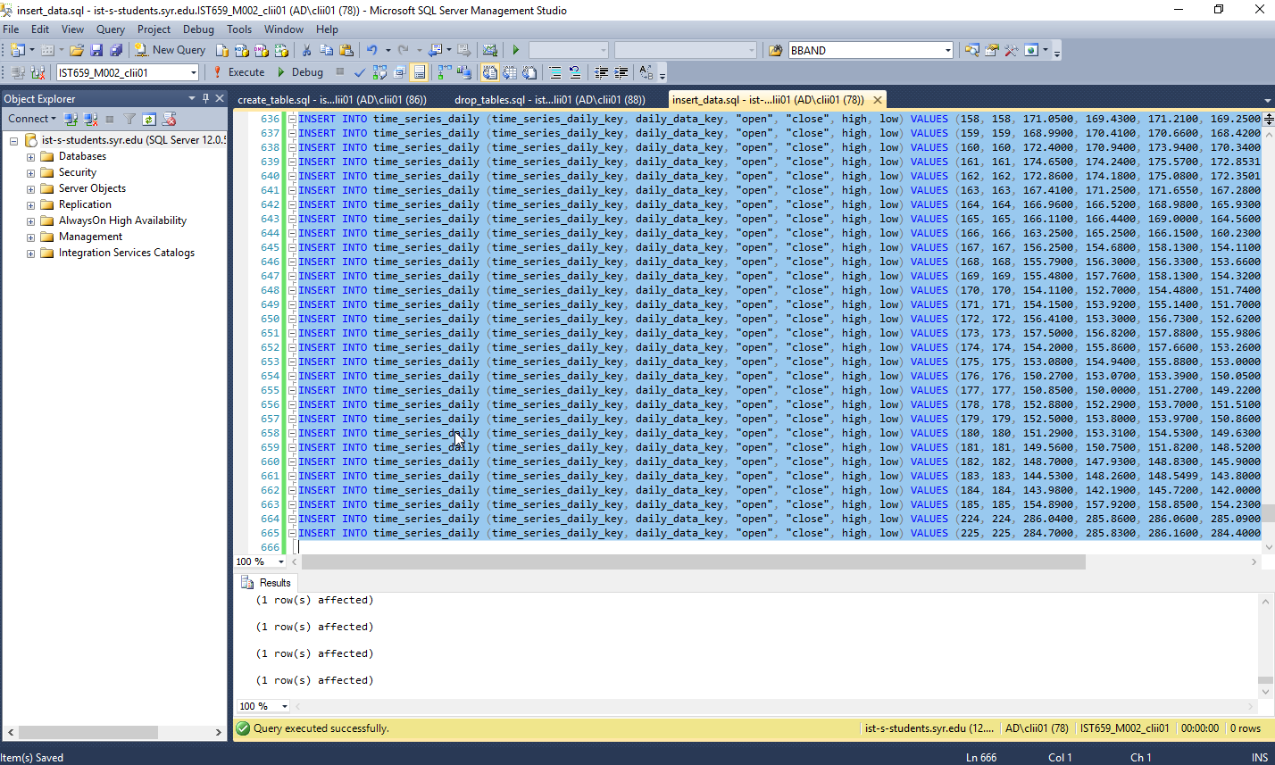

# Data Questions

## Get all the stock price data for a particular day

SELECT *

FROM daily_data

join time_series_daily

on daily_data.daily_data_key = time_series_daily.daily_data_key

join ema

on daily_data.daily_data_key = ema.daily_data_key

join macd

on daily_data.daily_data_key = macd.daily_data_key;

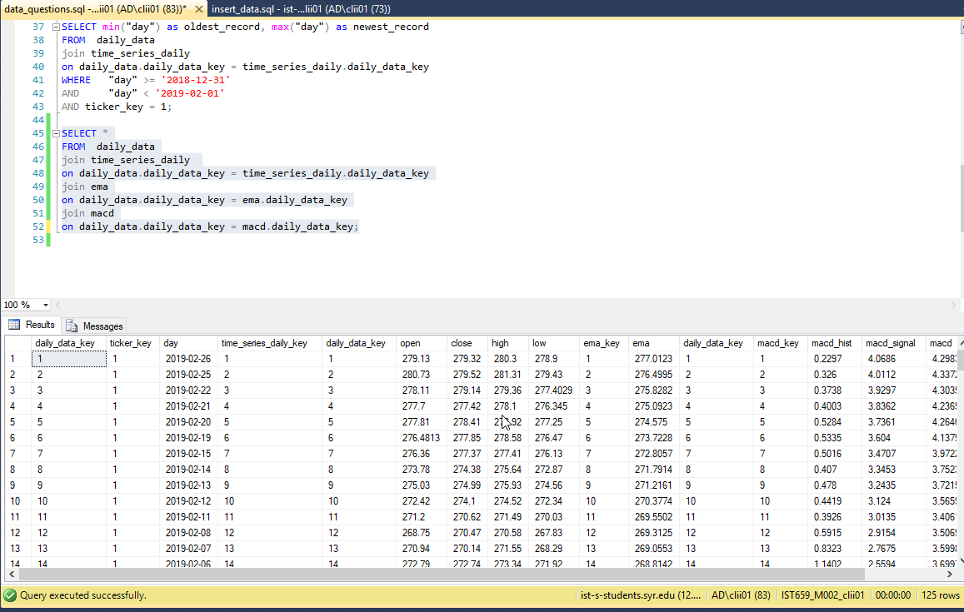

## Insert a new stock ticker into the ticker database

insert into ticker values(3, 'MSFT')

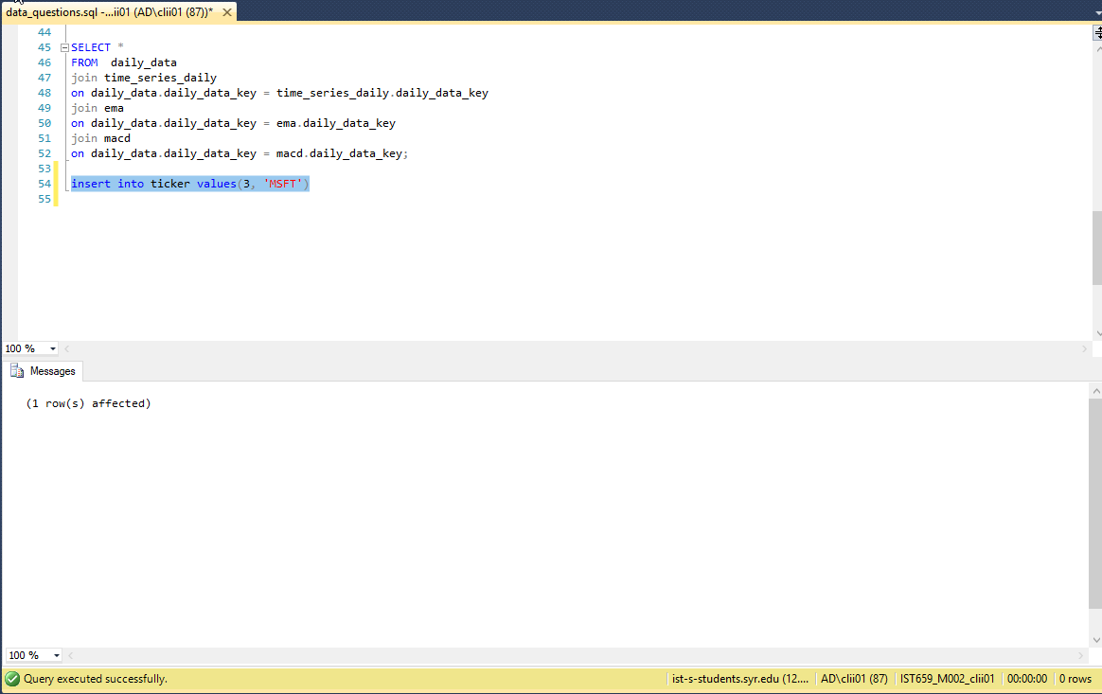

## Insert a new recommendation strategy and version into the database

INSERT INTO recommendation_strategy (recommendation_strategy_key, trend, name, description) VALUES (4, 'BULLISH', 'Bollinger Band Exit Bullish', 'Recommends user to buy calls to sell if the stock price average retreats from the lower Bollinger Band');

INSERT INTO recommendation_strategy_version (recommendation_strategy_version_key, recommendation_strategy_key, version) VALUES (4, 4, 1);

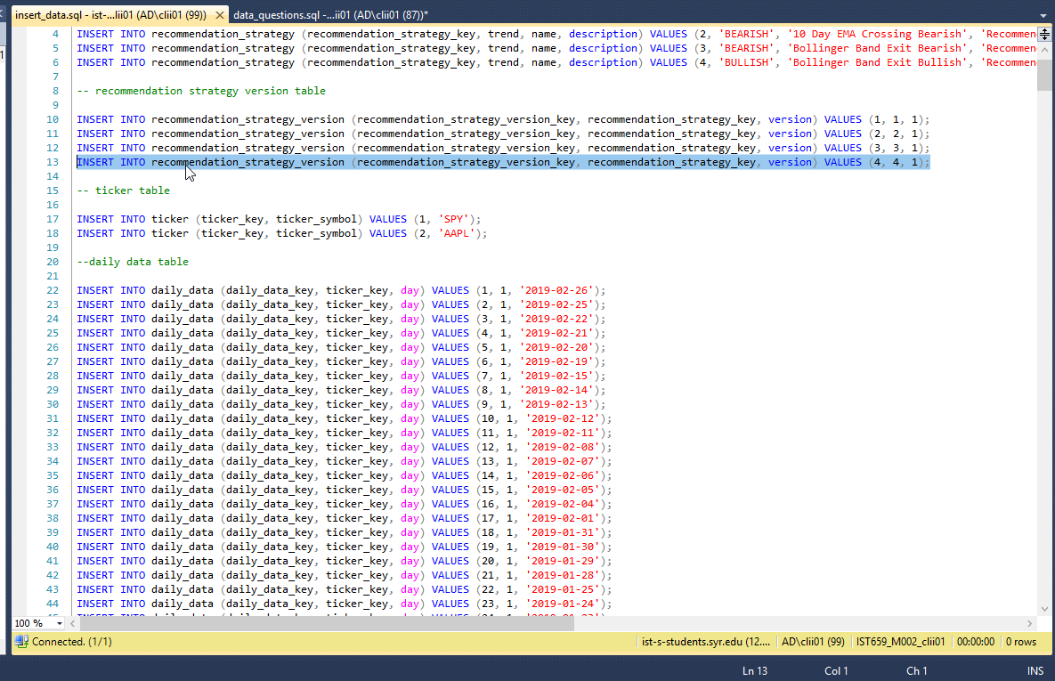

## Insert new backtest results

insert into backtest_result (backtest_result_key, recommendation_strategy_version_key, ticker_key, date_tested, days_to_hold, biggest_loss, successes, failures, fizzles, total, percent_success, percent_not_failed)

values (1, 1, 1, '2019-04-07', 2, 5.0, 5, 3, 2, 10, 0.5, 0.8);

insert into backtest_result (backtest_result_key, recommendation_strategy_version_key, ticker_key, date_tested, days_to_hold, biggest_loss, successes, failures, fizzles, total, percent_success, percent_not_failed)

values (2, 2, 1, '2019-04-07', 2, 5.0, 6, 3, 0, 9, 0.666665, 666665);

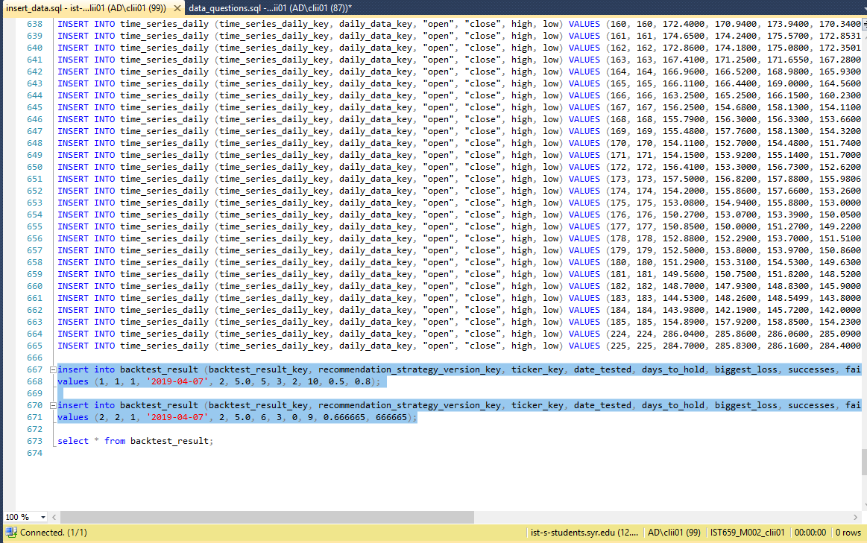

## Insert Daily Data

INSERT INTO daily_data (daily_data_key, ticker_key, day) VALUES (18, 1, '2019-01-31');

INSERT INTO daily_data (daily_data_key, ticker_key, day) VALUES (19, 1, '2019-01-30');

INSERT INTO bbands (bbands_key, real_middle_band, real_upper_band, real_lower_band, daily_data_key) VALUES (5, 273.2943, 279.0815, 267.5071, 5);

INSERT INTO ema (ema_key, ema, daily_data_key) VALUES (7, 272.8057, 7);

INSERT INTO macd (macd_key, macd_hist, macd_signal, macd, daily_data_key) VALUES (38, -0.0520, -6.2490, -6.3010, 38);

INSERT INTO time_series_daily (time_series_daily_key, daily_data_key, "open", "close", high, low) VALUES (1, 1, 279.1300, 279.3200, 280.3000, 278.9000);

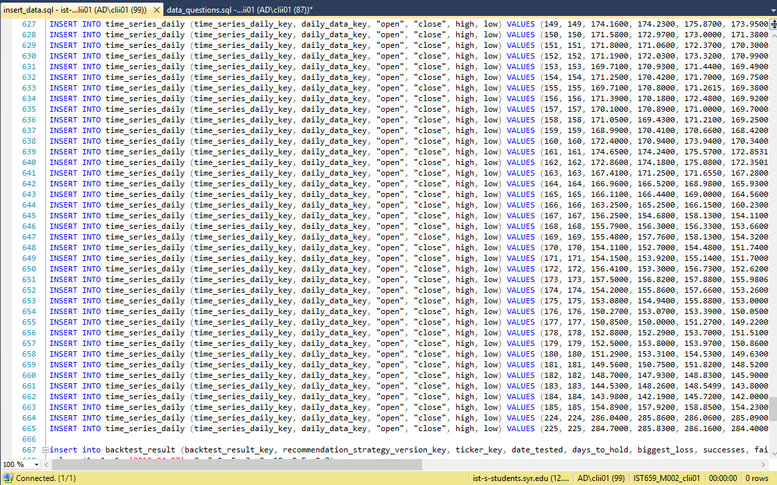

# Form and reports

## Daily data details lookup

If a user wants to get all the technical data for a particular day, this interface is for him

SELECT *

FROM dbo_daily_data, dbo_time_series_daily, dbo_bbands, dbo_ema, dbo_macd

WHERE dbo_daily_data.daily_data_key = dbo_time_series_daily.daily_data_key

AND dbo_daily_data.daily_data_key = dbo_bbands.daily_data_key

AND dbo_daily_data.daily_data_key = dbo_ema.daily_data_key

AND dbo_daily_data.daily_data_key = dbo_macd.daily_data_key;

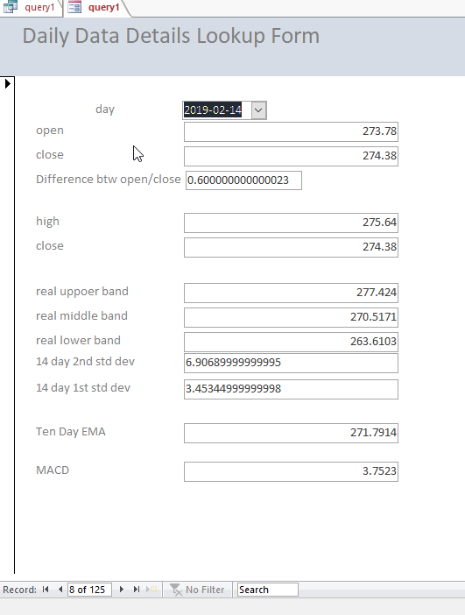

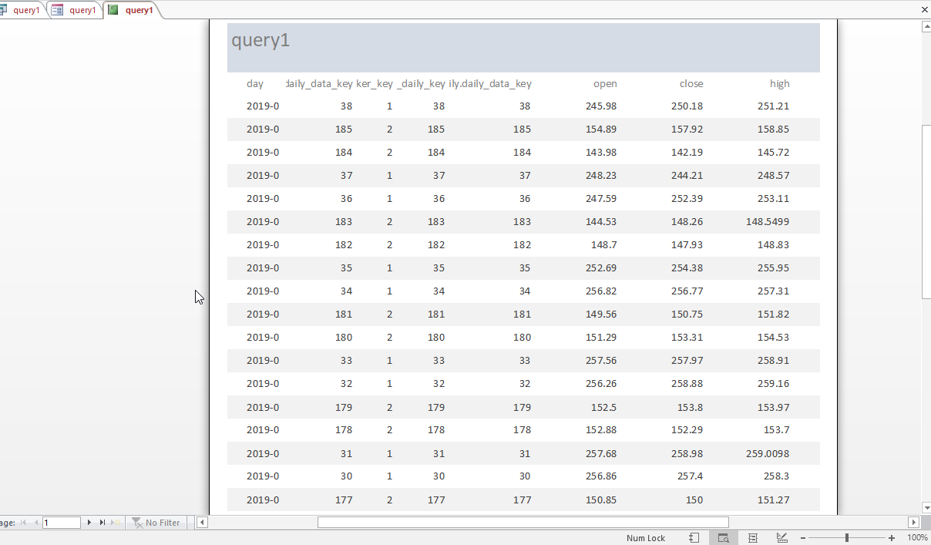

## Insert ticker symbol

If the user wants to insert a new stock symbol, this is the form and report for that

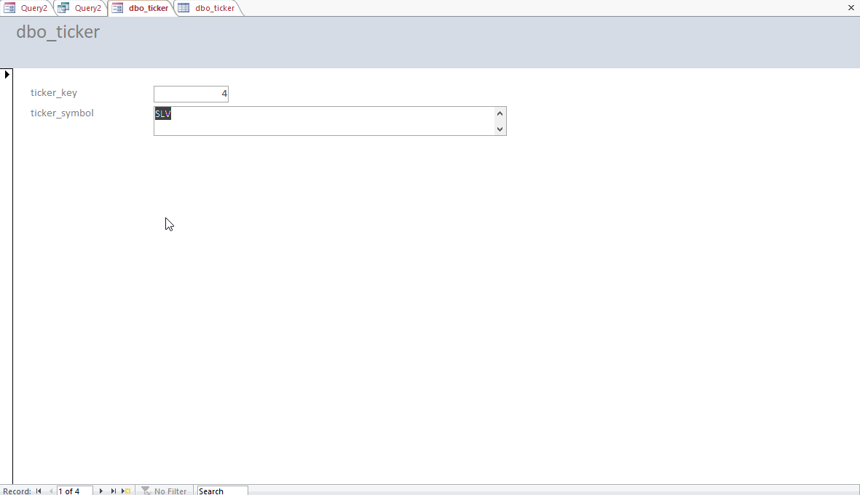

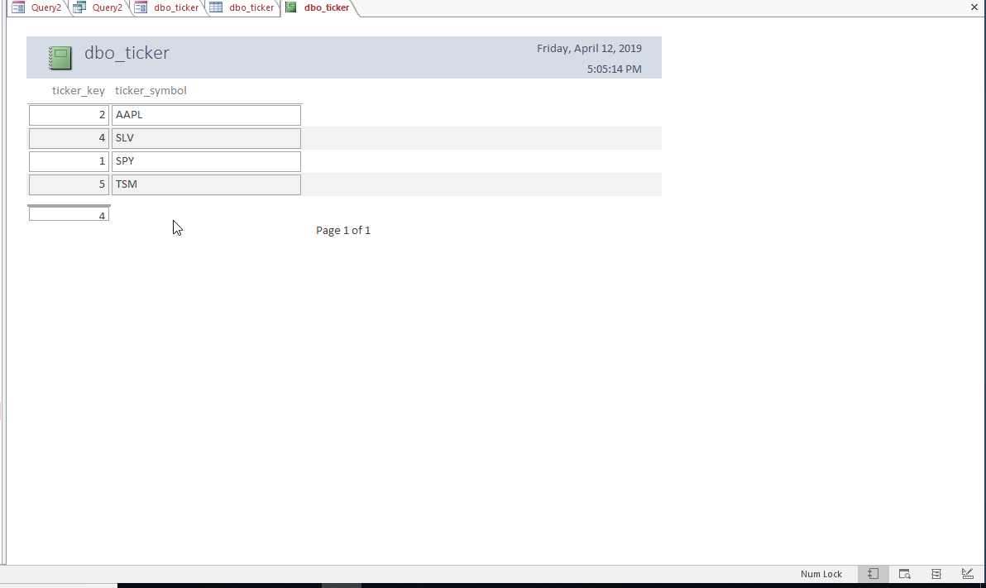

## Insert Recommendation Strategy and Version

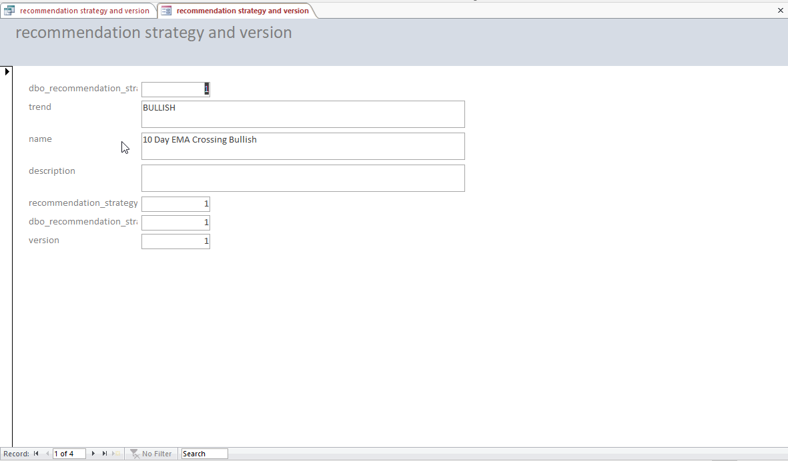

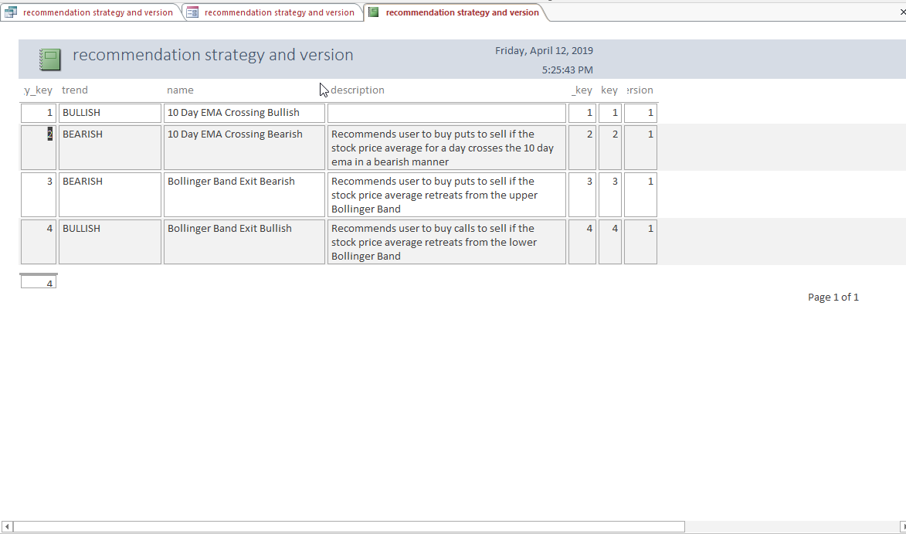

## Insert Backtest Results

Using this form one can insert backtest results into the database

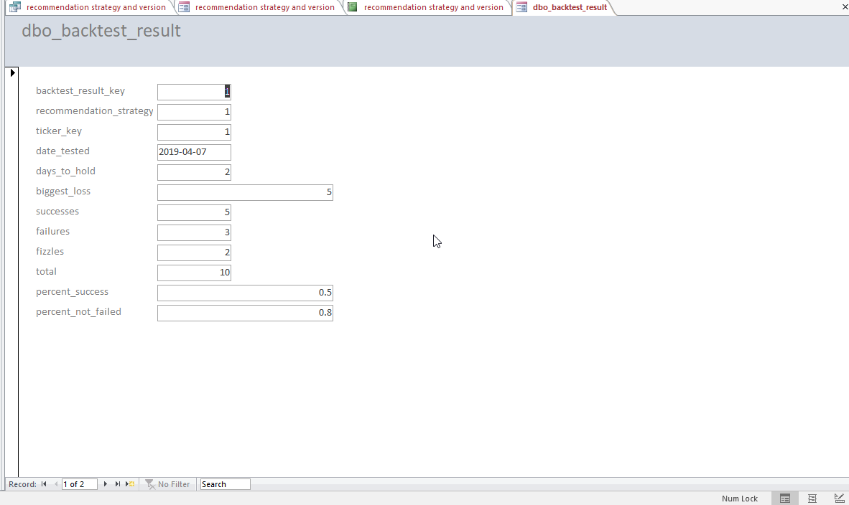

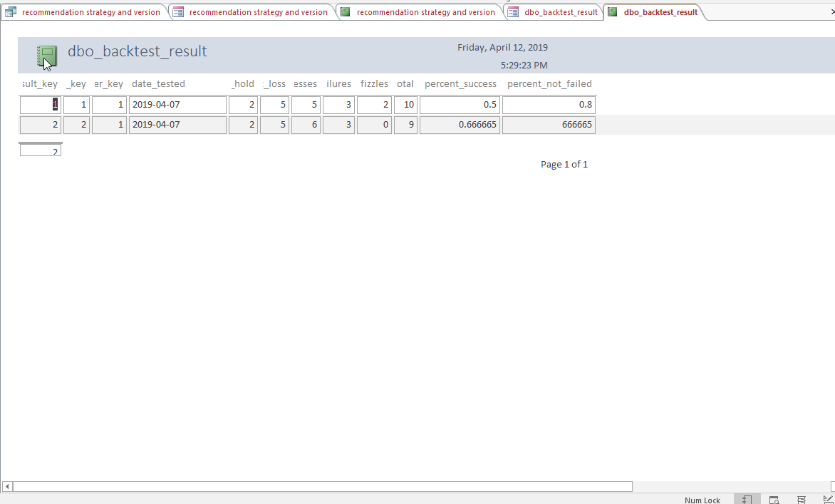

## Insert Daily Data

Form and report to insert daily data

